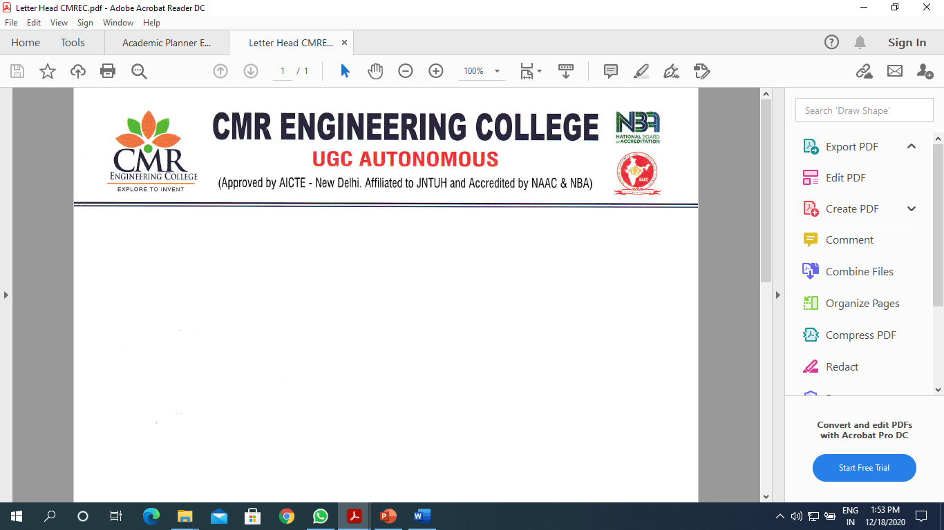

DEPARTMENT OF COMPUTER SCIENCE AND ENGINEERING
Artificial Intelligence (AI) Club
AI CLUB ACTIVITY LIST: III-I SEM (2024-25)
Sl No | Week # | Proposed Activity | Remarks
1 | 08th Sep 2024 | Club members Registration.
2 | 16th to 23rd Sep 2024 | Started working on Real time Projects related to AI
3 | 30th to 07th Sep 2024 | Demonstration about various Domains to Club Students.
4 | 07th to 14th Oct 2024 | Project Title Selections
5 | 11th to 18th Nov 2024 | Project Executions
6 | 12th Nov 2024 | Organized Workshop on “Generative AI”
7 | 25th to 09 Dec 2024 | Executions of Projects.

AI CLUB Coordinator HOD (CSE)

DEPARTMENT OF COMPUTER SCIENCE AND ENGINEERING
Artificial Intelligence (AI) Club
AI CLUB ACTIVITY LIST: III-II SEM (2024-25)
Sl No | Week # | Proposed Activity | Remarks
1 | 18th Jan 2025 | Event – Poster Presentation on Projects  (Dept Level Event)
2 | 25th to 01st Feb 2025 | Start working on Real time Projects related to Machine Learning
3 | 08th to 15th Feb 2025 | Demonstration about various Domains, Techniques on Projects to Club Students.
4 | 22nd to 01st Mar 2025 | Project Title Selections
5 | 01st to 08th Mar 2025 | Explaining about Techniques, Algorithms of projects & Executions
6 | 15th to 22nd Mar 2025 | Executions of Projects.
7 | 22nd to 05th Apr 2025 | Make the each students to participate in atleast one Activity (Outside College) and giving presentations of their projects.

AI CLUB Coordinator HOD (CSE)

