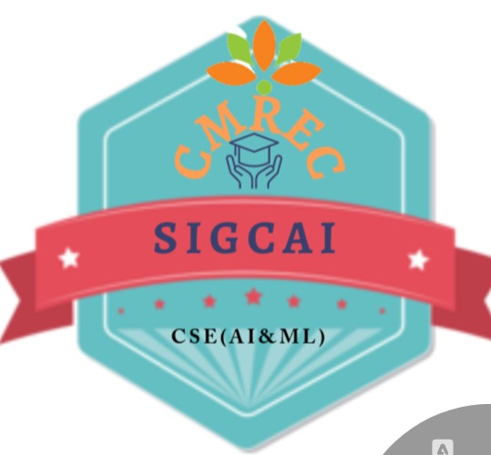

**INDEX FOR COMPUTER SOCIETY OF INDIA (CSI)**

**C A Y - 2023-2024**

|  |  |  |  |
| --- | --- | --- | --- |
| **S.No.** | **Name of the event** | **Date** | **Expert Details** |
| 1 | Inauguration Ceremony |  |  |
| 2 | Achieving Operational Efficiencies Through AI and ML | 18-10-2023 | Mr. Sharath Babu,  Director, Technical APAC Regional Solution, Production Engineering,  Iron Mountain Services Private Limited, Bangalore |
| 3 | Cyber Awareness Program | 08-12-2023 | Wg.Cdr.G.Srinivasu(Retd),  Director, MILSTAR RF Technologies Pvt.Ltd |
| 4 | Cyber Suraksha in Rural India | 08-12-2023 | Wg.Cdr.G.Srinivasu(Retd),  Director, MILSTAR RF Technologies Pvt.Ltd |
| 5 | Navigating the Future: Tomorrow’s Technology and Sills for Engineers | 06-01-2024 | Mrs.Rama Savithri Dabbeeru,  EX-CEO WE-ITC(ALEAP),EX-ORACLE GLOBAL TECHNICAL Head |
| 6 | Cyber Crime: Mobile and Wireless Device | 02-03-2024 | Mr.Rupesh Mittal,  Cyber Consultant Founder of Cyber Jagruthi Foundation, Hyderabad. |
| 7 | Generative AI tools Business Impact | 09-11-2024 | Mr. Sharath Babu,  Director, Technical APAC Regional Solution, Production Engineering,  Iron Mountain Services Private Limited, Bangalore. |

**INDEX FOR COMPUTER SOCIETY OF INDIA (CSI)**

**C A Y - 2024-2025**

|  |  |  |  |
| --- | --- | --- | --- |
| **S.No.** | **Name of the event** | **Date** | **Expert Details** |
| 1 | Artificial Intelligence Tools | 10-01-2025 | Mr. Venkata Sai . D  Data Scientist, Bepec Solutions,  Bangalore. |

|  |  |
| --- | --- |
| **C:\Users\DS90\Downloads\WhatsApp Image 2025-01-10 at 8.57.46 AM.jpeg** | **C:\Users\DS90\Desktop\7caa02db-ba7e-4518-9cda-3c4a8b0c7760.jpg** |
| **C:\Users\DS90\Desktop\87427c17-ab58-4765-ac65-1196bcf2a790.jpg** | **C:\Users\DS90\Desktop\5f3adecb-0649-4b06-ad1d-37ea8f7641c2.jpg** |