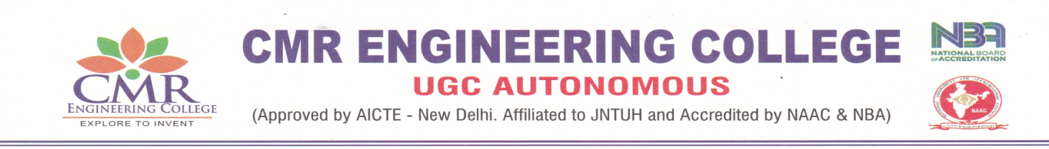
DEPARTMENT OF ELECTRONICS AND COMMUNICATION ENGINEERING
List of faculty members obtained certification of MOOCs
A.Y: 2022-23

S.No. | Name of the Faculty | Name of Course Passed | Course Offered by (agency) | Grade obtained if any
1 | Dr.SUMAN MISHRA | INTRODUCTION TO INTERNET OF THINGS | IIT KHARAGPUR | ELITE + SILVER  (TOPPER)
1 | Dr.SUMAN MISHRA | COMPUTER NETWORKS AND INTERNET PROTOCOL | IIT KHARAGPUR | ELITE
2 | Dr. S.RAMA KISHORE REDDY | THE JOY OF COMPUTING USING PYTHON | IIT MADRAS | ELITE + SILVER
2 | Dr. S.RAMA KISHORE REDDY | COMPUTER NETWORKS AND INTERNET PROTOCOL | IIT KHARAGPUR | ELITE
2 | Dr. S.RAMA KISHORE REDDY | INTRODUCTION TO INTERNET OF THINGS | IIT KHARAGPUR | ELITE + SILVER
3 | Dr.S.POONGODI | INTRODUCTION TO SOFT COMPUTING | IIT KHARAGPUR | ELITE
4 | Dr.NALABOTHULA ARAVINDHA | COMPUTER NETWORKS AND INTERNET PROTOCOL | IIT KHARAGPUR | ELITE + SILVER  (TOPPER)
5 | ALURI GOPI | CRYPTOGRAPHY AND NETWORK SECURITY | IIT KHARAGPUR | SUCCESSFULLY COMPLETED
5 | ALURI GOPI | COMPILER DESIGN | IIT KHARAGPUR | SUCCESSFULLY COMPLETED
5 | ALURI GOPI | CLOUD COMPUTING | IIT KHARAGPUR | ELITE

- No.of Faculty certified: 05
- Total number of certified courses: 10

Coordinator HoD

