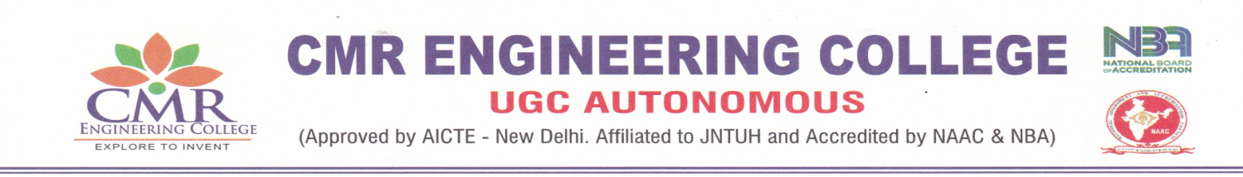
DEPARTMENT OF ELECTRONICS AND COMMUNICATION

DEPARTMENT OF ELECTRONICS AND COMMUNICATION ENGINEERING
List of faculty members obtained certification of MOOCs
A.Y: 2021-22

S.No. | Name of the Faculty | Name of Course Passed | Course Offered by (agency) | Grade obtained if any
1 | DR.S.POONGODI | DEEP LEARNING | IIT MADRAS | SUCCESSFULLY COMPLETED
2 | ALURI GOPI | COMPUTER NETWORKS AND INTERNET PROTOCOL | IIT KHARAGPUR | SUCCESSFULLY COMPLETED
3 | Dr. B.SIVA KUMAR REDDY | INTRODUCTION TO MACHINE LEARNING | IIT KHARAGPUR | ELITE
4 | Dr. BHASKER DAPPURI | INTRODUCTION TO MACHINE LEARNING | IIT MADRAS | ELITE
4 | Dr. BHASKER DAPPURI | THE JOY OF COMPUTING USING PYTHON | IIT MADRAS | ELITE
4 | Dr. BHASKER DAPPURI | DEEP LEARNING | IIT MADRAS | SUCCESSFULLY COMPLETED

- No.of Faculty certified: 04
- Total number of certified courses: 06

Coordinator HoD

