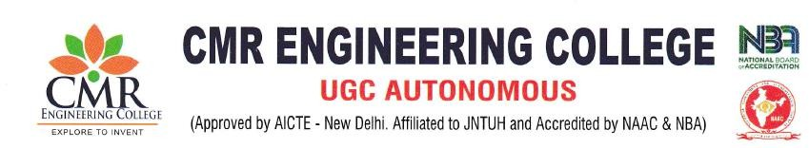
DepartmentofInformationTechnology

Sessions/Seminars Index AcademicYear:2024-2025
S.No | EventName | ResourcePersonName | DateOf Event | No. Of participants | Coordinator Name
1 | ASessiononThe CreativityCorner | Dr.XS.AshaShiny, Professor, CMREC | 22.06.2024 | 60 | Mrs. K.Sushma, AssistantProfessor
2 | A Session on Accelerators / Incubation- Opportunitiesfor Students  &Faculty-EarlyStage Entrepreneurs | Prof.AhmedOnsy,Deputy Head School of Engineering for Business Development and Partnerships, School of Engineering and Computing, UCLan, UK. | 08-08-2024 | 100 | Mrs. K.Sushma, AssistantProfessor
3 | A Session onAchieving Problem- SolutionFit&Product- Market Fit | Mr. V. Venkat Ram, AssistantProf,MCET, Hyderabad. | 24.01.2025 | 70 | Mrs. K.Sushma, AssistantProfessor

ASession Report

On
“TheCreativityCorner”

Title of Event :ASessiononTheCreativityCorner Date of Event : 22.06.2024
Venue :B-304
Resource Person : Dr. XS. Asha Shiny, Professor, CMREC Coordinators :Mrs.K.Sushma,AssistantProfessorofIT. Student Attended : 60

Aim&Objective:
The main aim of The Creativity Corner has provided rich and varied experiences to the students, thereby building their knowledge, boosting creativity skills, increasing confidence, valuing team work and developing leadership qualities.
Description
On the 22nd of June, 2024, Department of Information Technology , CMR Engineering College conducted A session on The Creativity Corner. The "Creativity Corner" is adedicated space designed to inspire and cultivate creative thinking and innovation. This area is typically equipped with a range of resources such as brainstorming tools, prototyping materials, and interactive technology. It features a stimulating environment with dynamic decor, inspirational artwork, and comfortable seating arrangements that encourage open idea sharing and collaboration.
Objectives:
- EncourageInnovativeThinking
- FacilitateCollaboration
- SupportPersonalandProfessionalGrowth
- EncourageRisk-TakingandExperimentation

Benefitsintermsoflearning/skill/Knowledge
  - FacilitateIdeaGenerationandDevelopment
  - EncourageContinuousLearning
  - TrackandShowcaseProgress
  - EnhancedInnovation
  - BetterProblem-Solving

Attachments:

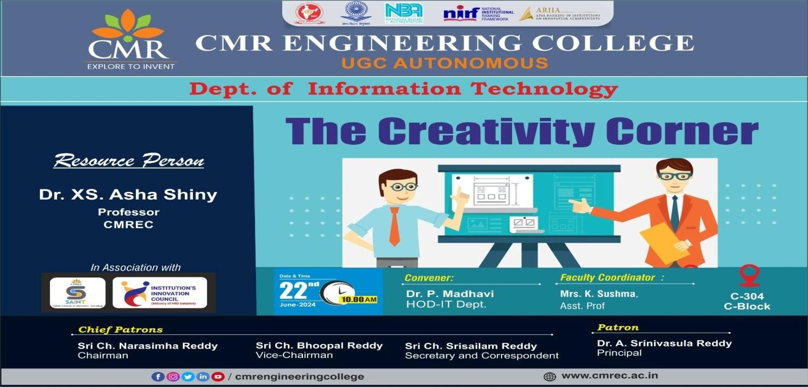

Photographs*
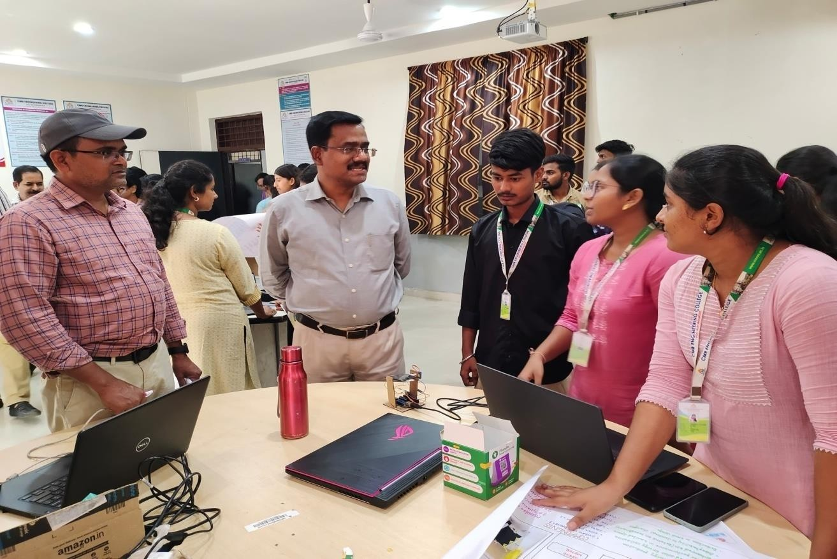
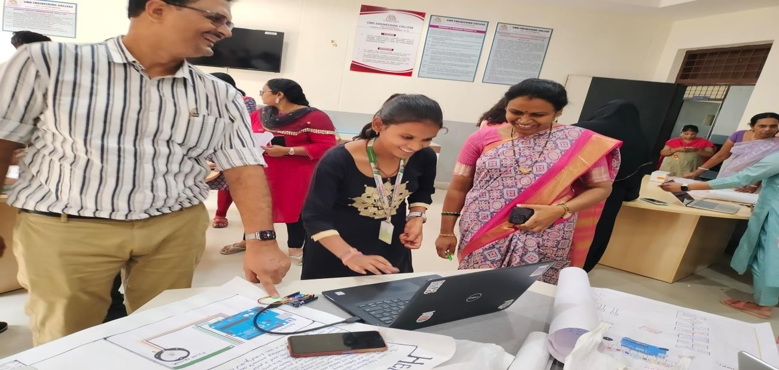

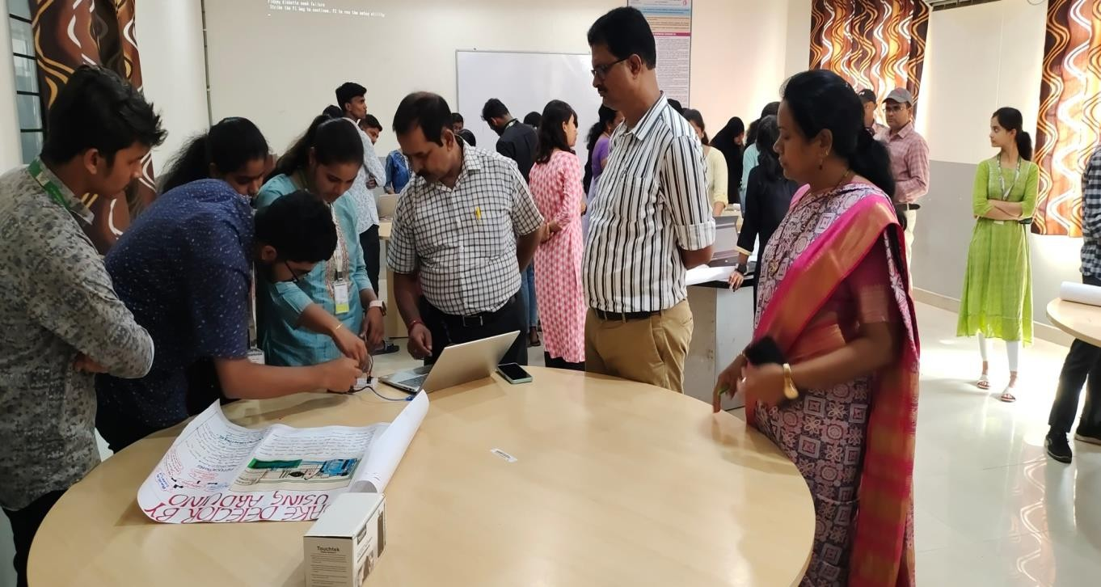

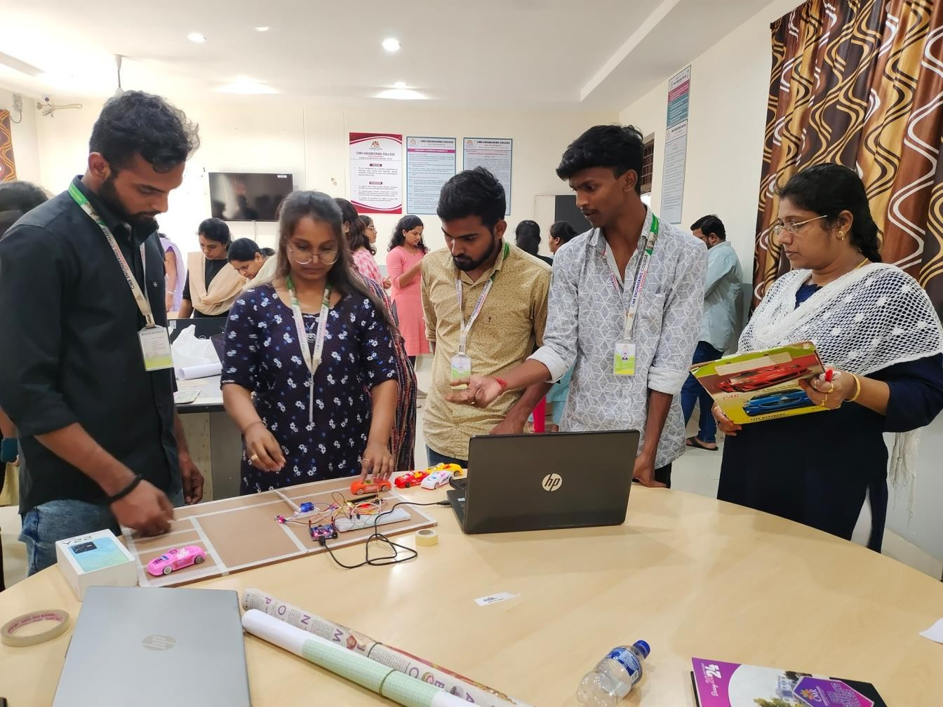

DepartmentofInformationTechnology

ASession Report

On
Accelerators/Incubation-OpportunitiesforStudents&Faculty-EarlyStage Entrepreneurs
Title of Event :A Session on Accelerators / Incubation-Opportunitiesfor Students & Faculty-Early Stage Entrepreneurs
DateofEvent :08.08.2024
Venue :Block-1Auditorium
Resource Person :Prof.AhmedOnsy,DeputyHeadSchoolofEngineering forBusiness Development and Partnerships, School of Engineering and Computing, UCLan, UK.
Coordinators :Mrs.K.Sushma, AssistantProfessorofIT.
StudentAttended :100

Aim&Objective:
The main aim of Accelerators and incubation programs can help early-stage entrepreneurs, including students and faculty, launch and grow their businesses through resources, mentorship, and funding. These programs can also help entrepreneurs connect with other entrepreneurs, investors, and industry experts.

Description
On the 08thof august, 2024, Department of Information Technology , CMR Engineering College conducted A session on Accelerators / Incubation-Opportunities for Students & Faculty-Early Stage Entrepreneurs. Accelerators and incubation programs can be especially helpful for entrepreneurs who don't have previous startup experience. Incubators tend tofocus on supporting early-stage startups with an idea and founders, helping to nurture those ideas into businesses. Accelerators, on the other hand, tend to focus on helping more established startups grow and scale through educational programs and mentorship.

Objectives:

- MentorshipandGuidance
- FundingandInvestment
- MarketValidationandFeedback
- OperationalSupport

Benefitsintermsoflearning/skill/Knowledge

  - PrototypeandProductDevelopment
  - CommunityBuilding
  - SkillDevelopment
  - Exposureand Visibility

Attachments:

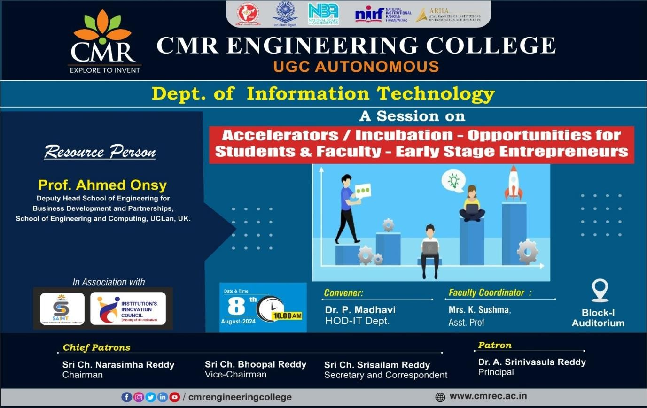

Photographs*

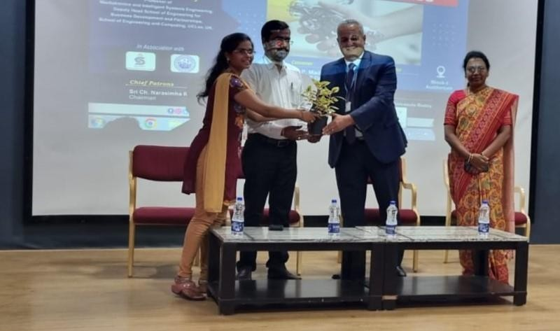

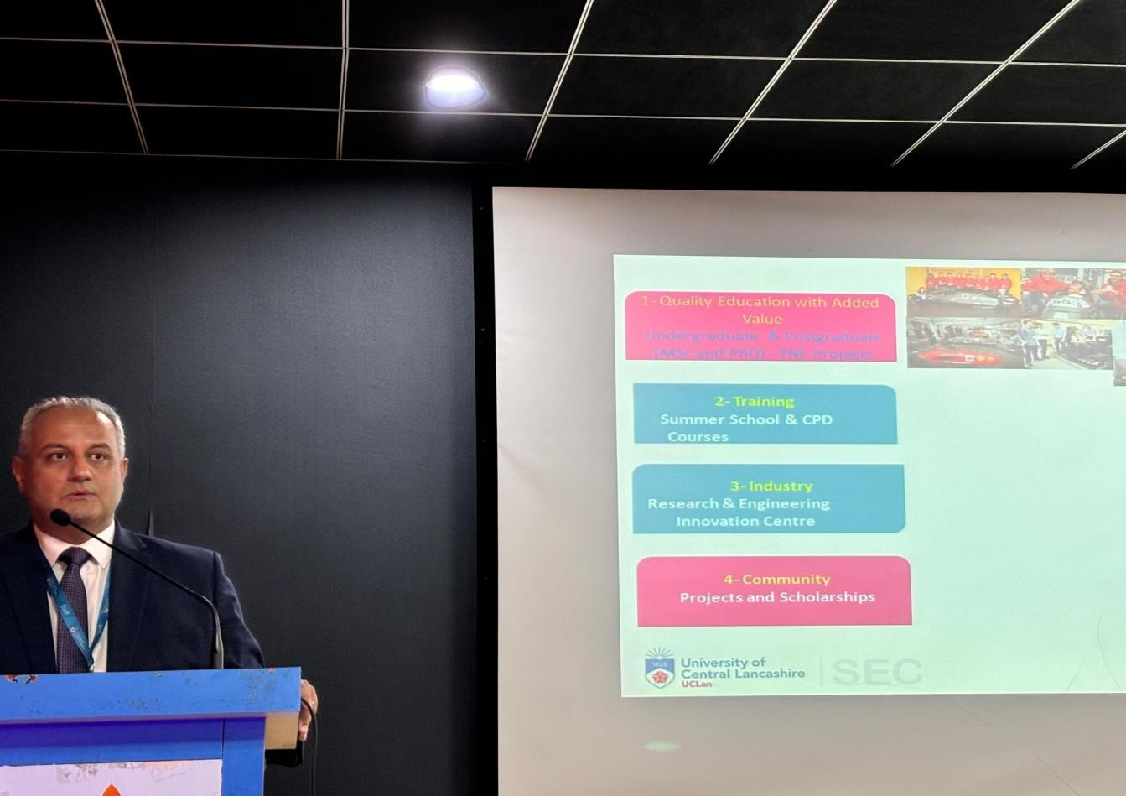

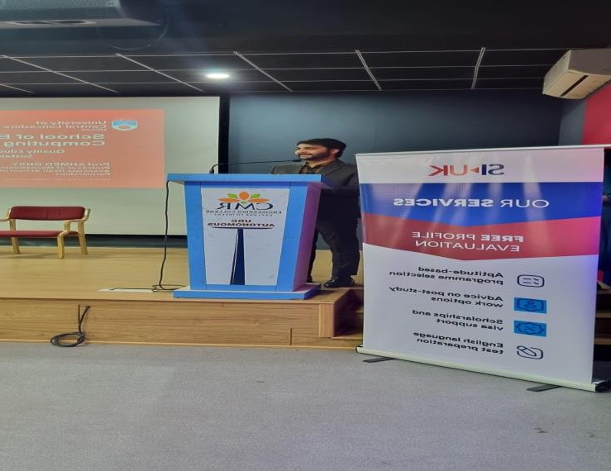
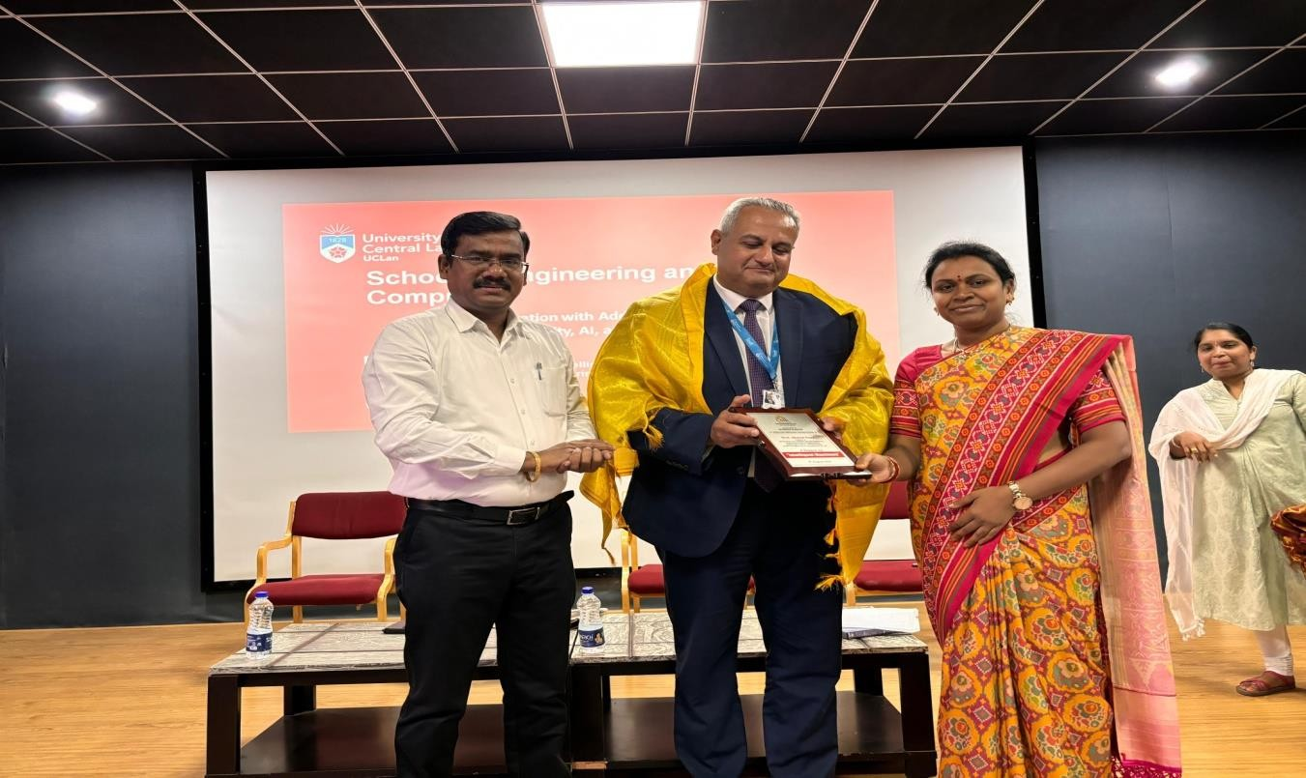

ASessionon
AchievingProblem-SolutionFit&Product-MarketFit
TitleofEvent : ASessiononAchievingProblem-SolutionFit&Product-Market Fit
DateofEvent :24/01/2025
Venue :C-310
ResourcePerson :Mr.V.VenkarRam,Assistant.Prof,MCET,Hyderabad.
Coordinators :Mrs.K.Sushma, AssistantProfessorofIT.
StudentAttended :70
Description:This specific lecture gives importance of Problem- Solution and Product- Market, A problem-solution fit is when a startup has identified a problemthat its product or servicecansolve. It’sastartup’s initialvalidationthat itssolutionactuallysolvestheproblem it setouttosolve foraparticulartarget market. Product-market fit referstothemoment when a startup finally finds the right market for its product. This is an important milestone for any startup, as it can mean the difference between success and failure.

Benefitsintermsoflearning/skill/Knowledge

- Growingyourcompanyatafastrate.
- Acquiringconsumersatalowcost.
- Keepingconsumersloyalandhappy.
- Abilitytoscale easilywhenneeded.
Attachments:
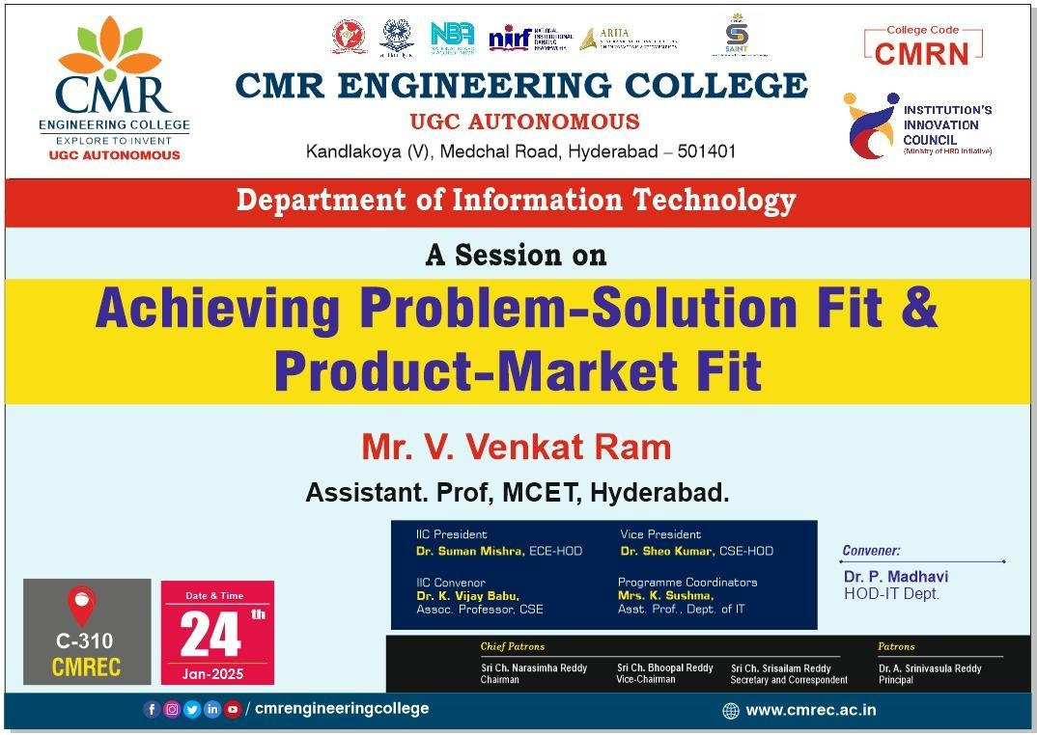

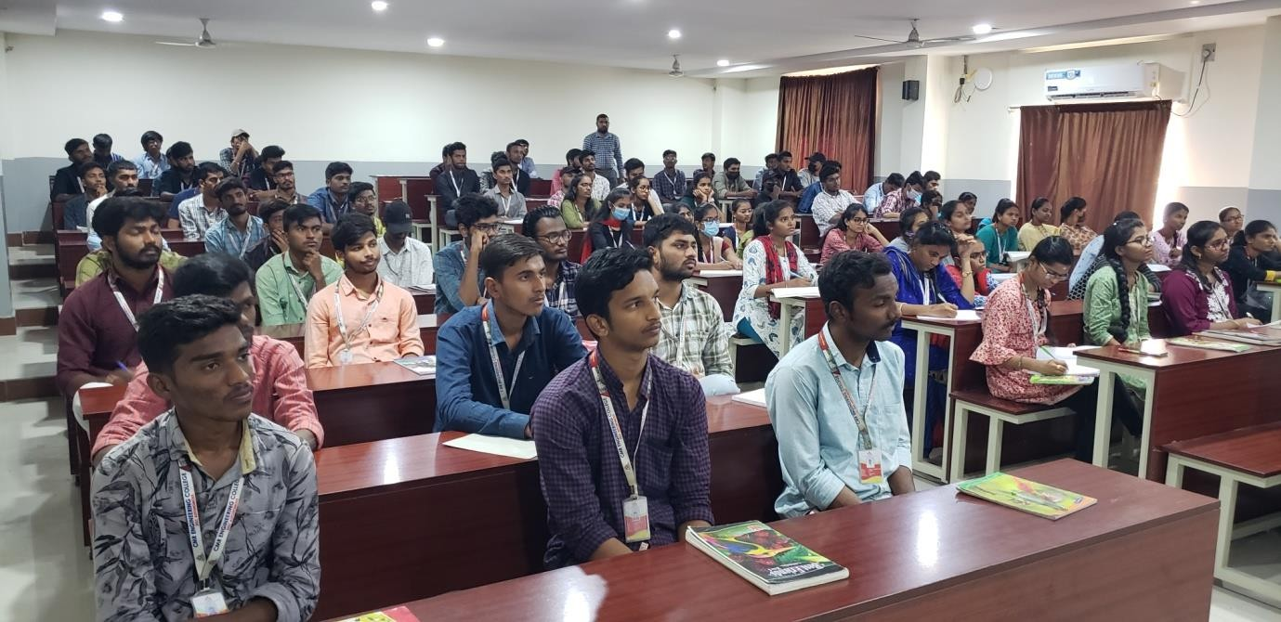

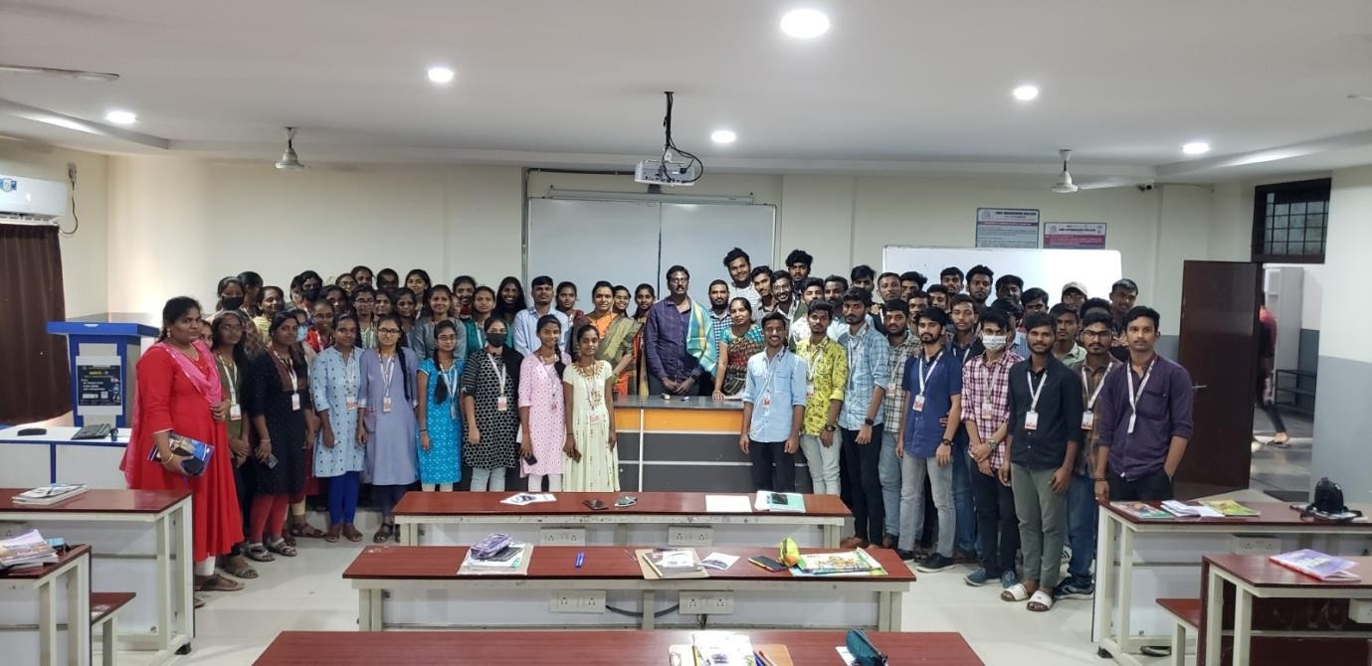

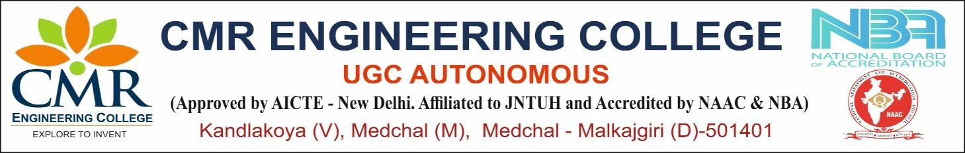
DepartmentofInformationTechnology
STTP Programs Index AcademicYear:2024-2025
S.No | EventName | ResourcePersonName | DateOf Event | No. Of participants | Coordinator Name
1 | National Level Short- TermTrainingProgram on JAVA Full Stack with React JS & AI | Dr.BuddhaChandrashekar, Chief coordinating Officer AICTE | 02/12/2024  to 22/12/2024 | 80 | Ms.NSRAVANI,  AssistantProfessor Mrs.Suhasini, AssistantProfessor

ReportOn

Title of Event : National Level Short-Term Training Program on JAVA Full Stack with React JS & AI
Date of Event : 02/12/2024to22/12/2024 Total No. of Participants : 80
Total Faculty Participants: 17 TotalStudentParticipants: 63
StudentYear/sem : IIandIIIyear
Guest Speaker Name : Dr.BuddhaChandrashekar Venue : online
Coordinatoroftheevent : Ms.NSRAVANI, Mrs.Suhasini

Aim&Objective:
The mainaimofguest lectureistobringawarenessonJAVAFullStackwithReactJS&AI. Description

The short-term training programon JAVA Full Stack with React JS &AI was conducted to bring the awareness and knowledge about JAVA Full Stack with React JS & AI. The Guest Dr. Buddha Chandra shekar, chief coordinating officer, AICTE. He briefly explained all the concepts of JAVA full stack and Recat JS & AI. Students gained the knowledge and the lecture was very informative.
BenefitsintermsofLearning:
- studentsgained theknowledgeofJAVAfullstackwithReactJSand AI
- Theareaofapplicationsalsolearned.
SamplePhotographs
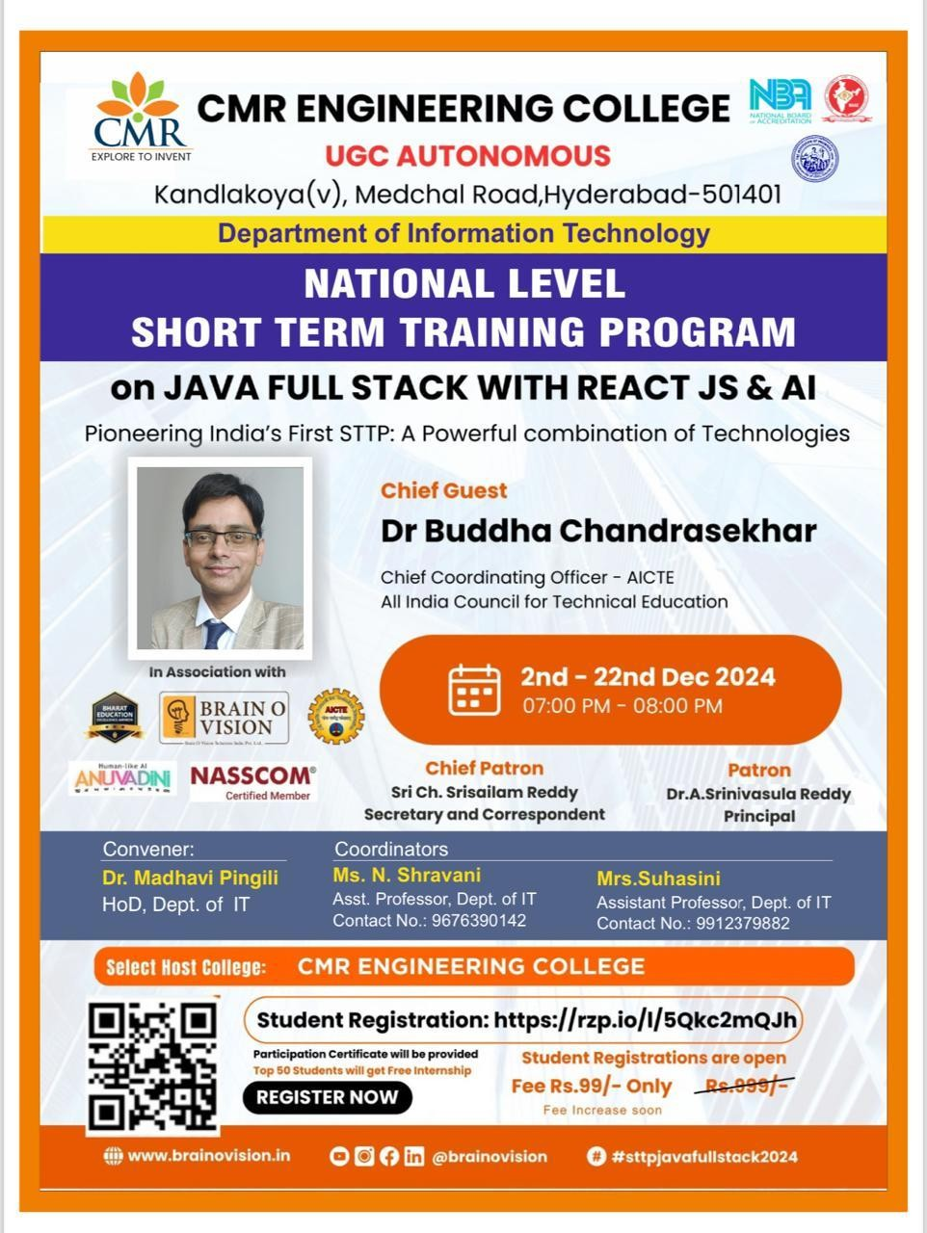

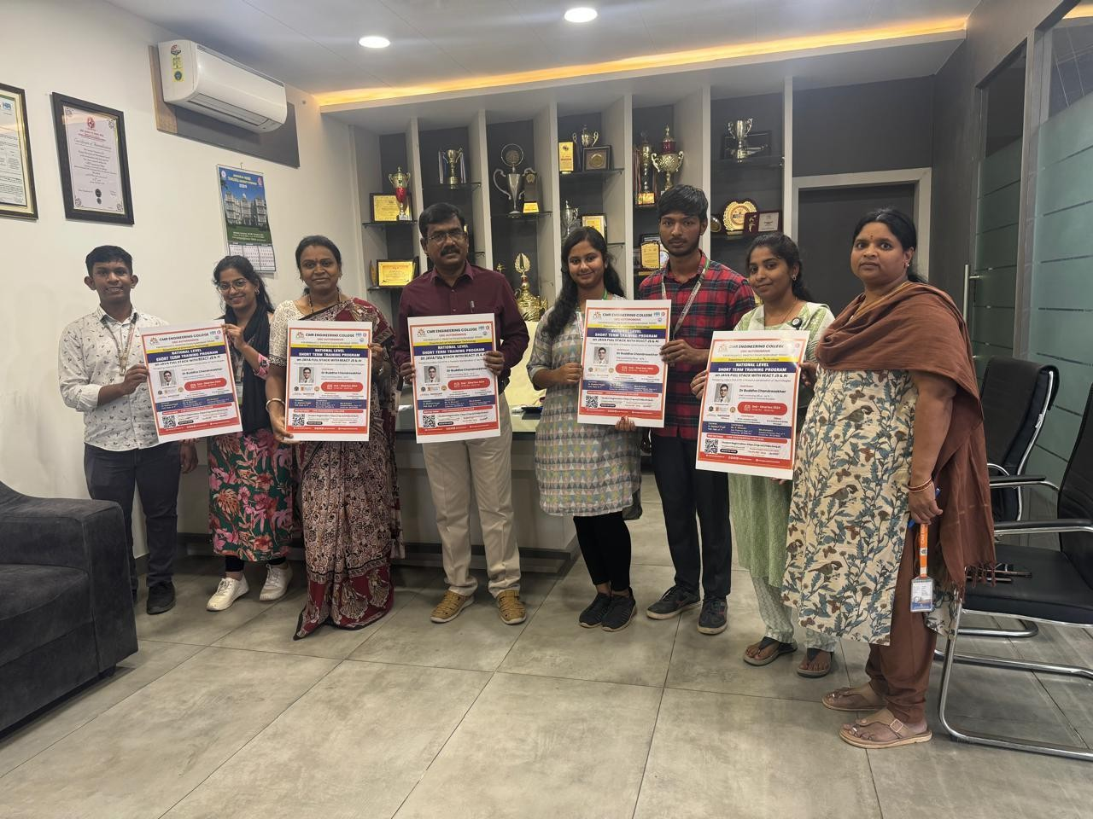

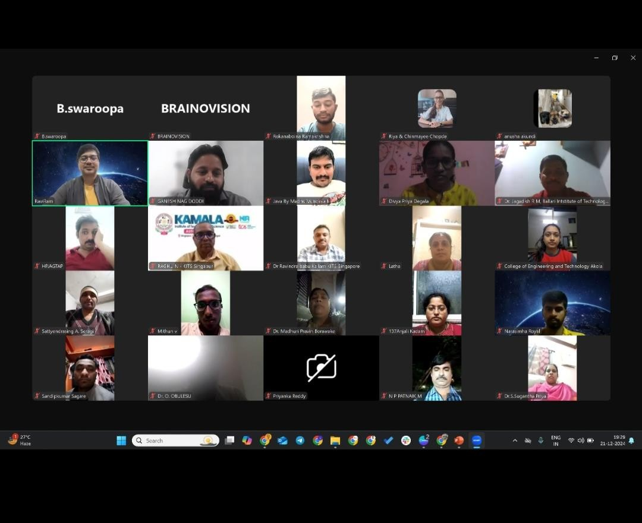

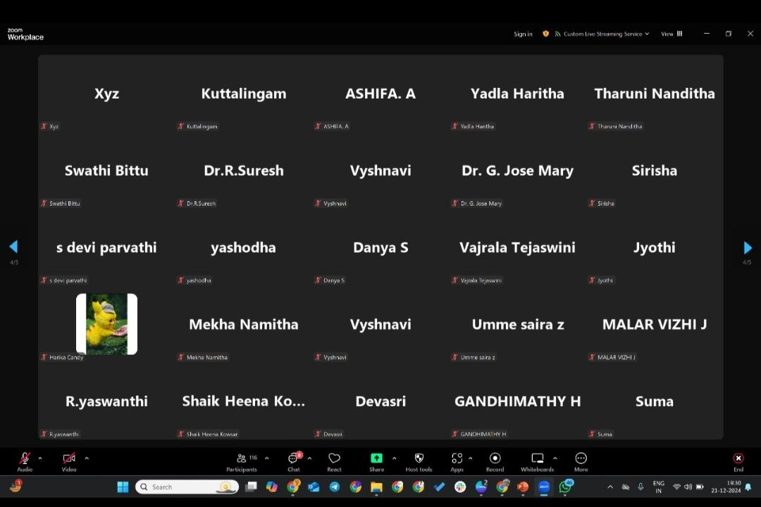

DepartmentofInformationTechnology

IdeaCompetition/ChallengeIndex Academic Year: 2024- 2025

S.No | EventName | ResourcePersonName | DateOf Event | No. Of participants | Coordinator Name
1 | An Event on Organize an Inter/Intra Institutional Idea Competition/Challenge  /Hackathon &Reward the Best Ideas and Deposition in the Institution’s YUKTHI Innovation Repository | Mrs.A.Soujanya,MCET, Hyderabad. | 10/12/2024  to 11/12/2024 | 80 | Mrs. K.Sushma, AssistantProfessor
2 | A Event on NEXTWAVE | Dr.X.S.AshaShinny Professor | 7/2/2025 | 100 | Mrs.Chinnam  Madhuri,Assistant Professor

AnEventon
Organize an Inter/Intra Institutional Idea Competition/Challenge/Hackathon&RewardtheBestIdeasand Deposition in the Institution’s YUKTHI Innovation Repository

Title of Event : An Event on Organize an Inter/Intra Institutional Idea Competition/Challenge/Hackathon & Reward the Best Ideas and Deposition in the Institution’s YUKTHI Innovation Repository.
DateofEvent :10/12/2024to11/12/2024
Venue :C-305
Resource Person : Mrs. A.Soujanya, MCET, Hyderabad. Coordinators :Mrs.K.Sushma,AssistantProfessorofIT. Student Attended : 80

Aim&Objective:

- TorewardtheideasthroughtheInstitutionalHackathon.
- ThestudentswererewardedfortheideasshowcasedduringtheInstitutionalHackathon

Description: National Innovation Repository (NIR) is an initiative of the Ministry of Education (MoE) Government of India and it is implemented by MoE’s Innovation Cell and AICTE to build a system of repository of ideas, innovations and startups developed in academic institutions and enabling institutions to systematically foster the I&E culture by managing and nurturing these innovations by offering continuous support in terms of one-to-one mentorship, grant assistance, referral and linkage with incubation units, connecting with Angel/Venture Capital (VC) investors network, knowledge agencies, etc.

Benefits:

- It provides an opportunity to participate in a National Level Contest organized by the Government of India.
- It provides a 360-degree experiential learning opportunities for innovators to work on their Prototypes/Innovations for market validations, IP Generation, Prototype/Innovation Refinement, Business Plan Development, Startup Formation, etc.
- You willget learningopportunitiesthroughaSeries ofMentoring,Training,and Handholding Activities for Innovators to develop innovations with a scalable and sustainable business model.

Attachments:
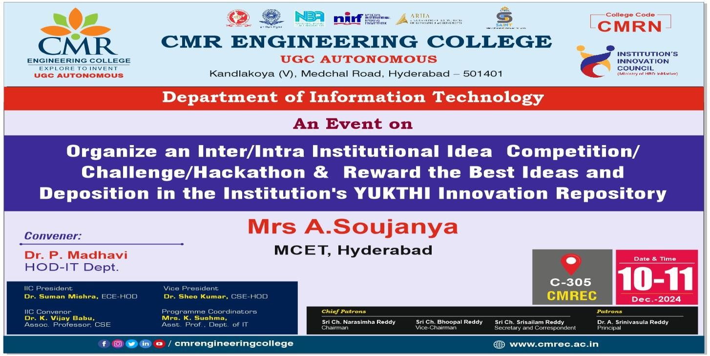

Photographs*

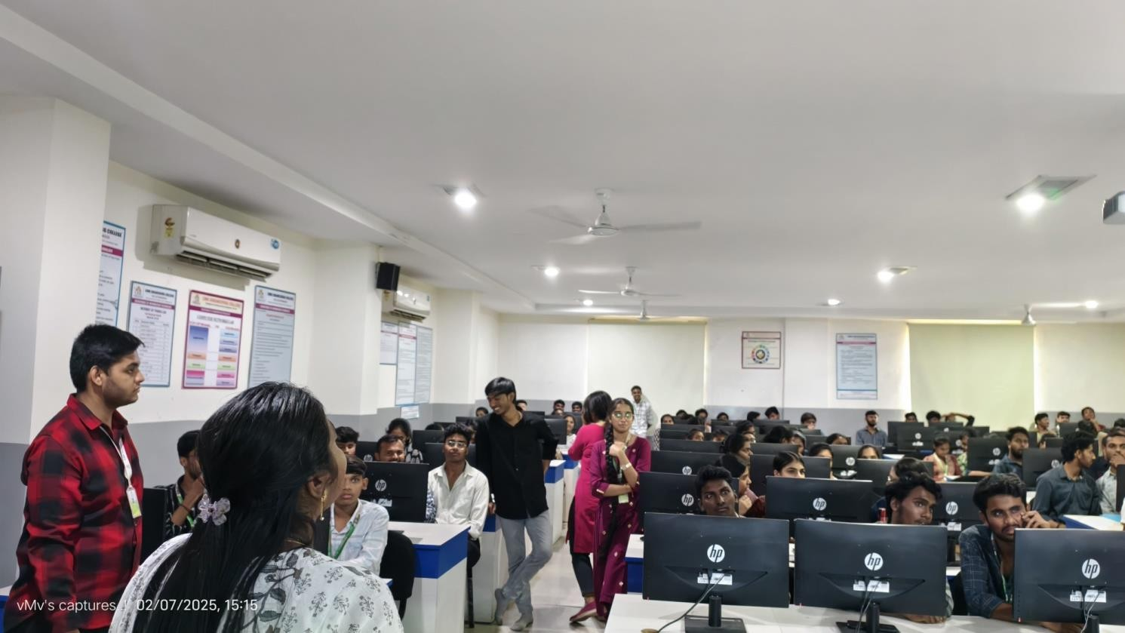

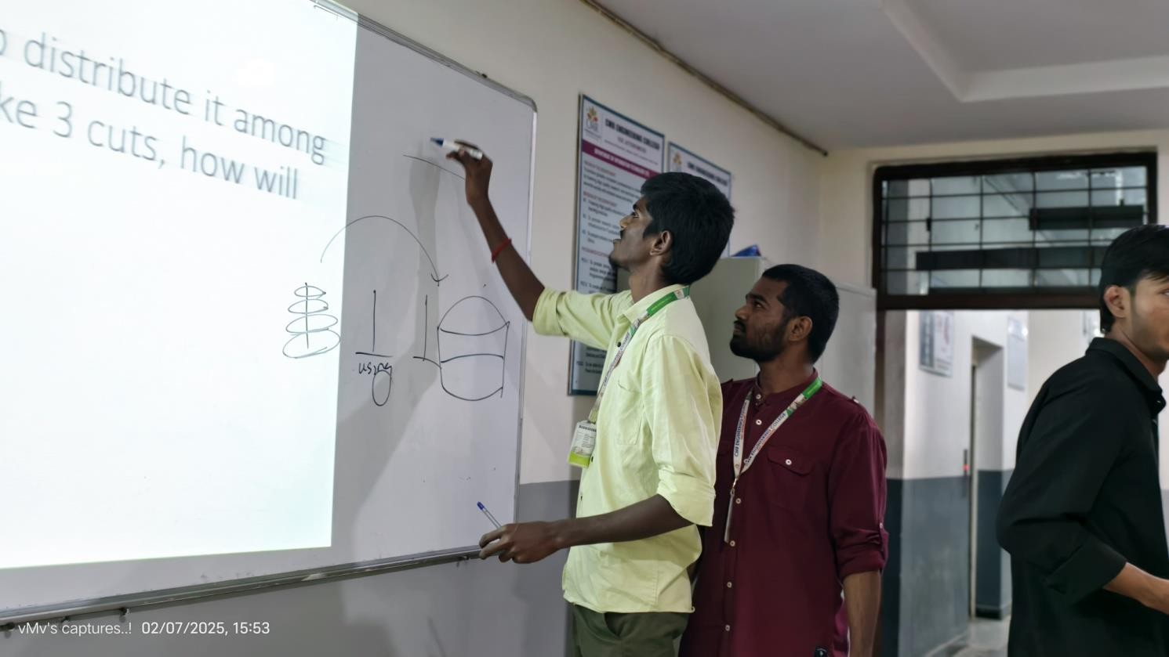

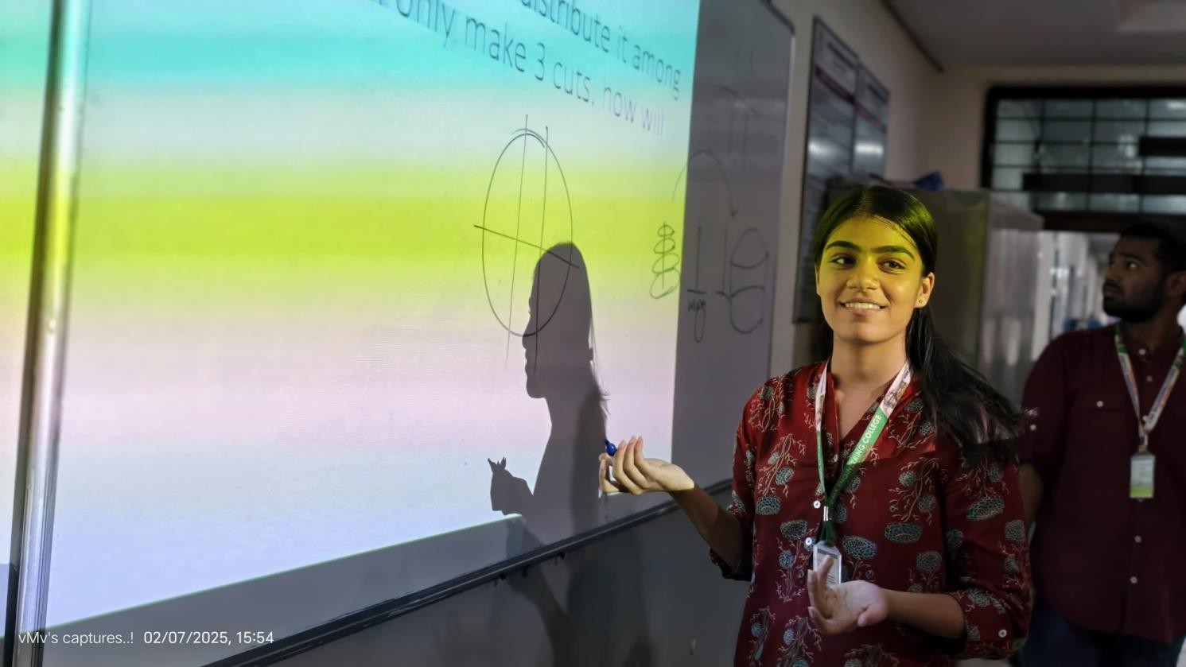

DepartmentofInformationTechnology

FDP Index AcademicYear:2024-2025

S.No | EventName | ResourcePersonName | DateOf Event | No. Of participants | Coordinator Name
1 | 1WeekNationalLevel Faculty Development ProgramonAITOOLS | Dr.BuddhaChandrashekar, Chief coordinating Officer AICTE | 17/02/2025  to 21/02/2025 | 80 | - Dr.X.S.Asha Shiny,Professor.  - Mrs.K.Sushma,  AssistantProfessor
AFDP Report

On
“AITOOLS”

TitleofEvent :1 WeekNationalLevelFacultyDevelopmentProgramonAITOOLS
DateofEvent :17/02/2025to21/02/2025
Venue :Online
ResourcePerson :Dr.BuddhaChandrashekar,ChiefcoordinatingOfficerAICTE
Coordinators :Dr.X.S.AshaShiny, Professor,Mrs.K.Sushma,AssistantProfessor
.

Aim&Objective:
The main aim of AI tools are has provided software applications that leverage artificial intelligence algorithms to perform tasks, solve problems, and make decisions, often automating processes and providing insights across various industries .
Description
From 17th of February, 2025, To 21st of February, 2025. Department of Information Technology, CMR Engineering College conducted A Faculty Development Program on AI TOOLS.

AI TOOLS simplifies complex topics or pieces of information into easy-to-understand explanations. Using the most advanced AI models, this tool breaks down complicated concepts into clear, concise, and easily understandable language.
AI tools aim to improve decision-making, automate tasks, enhance natural language processing, advance machine learning and data science, empower computer vision, personalize user experiences, promote ethical development, improve safetyand security, and foster human-AI collaboration.
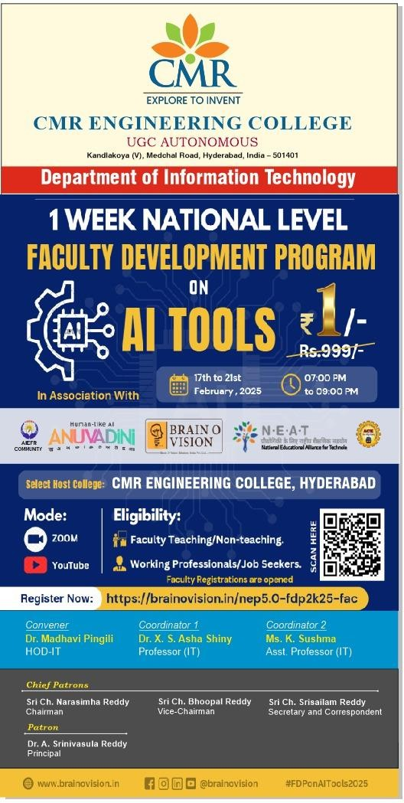
Attachments:

Photographs*
