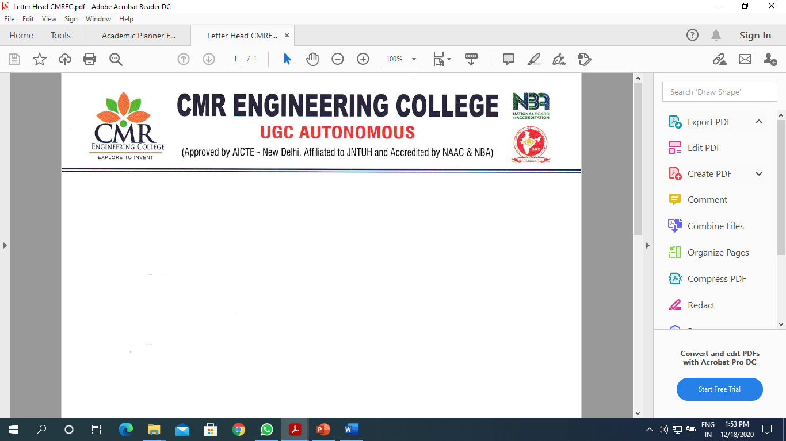
Department of Information Technology

A Report

On
“Expert Lecture Series on Block Chain Technology”

Title of Event : Expert Lecture Series on Block Chain Technology
Date of Event : 02/09/2025 to 03/09/2025
Venue : Block-D 401
Internal Expert : Dr. X.S Asha Shiny, Professor of IT.
Convener : Dr. M.Ashwitha Reddy , HOD-IT & CSE-CS dept
Coordinators : Mrs. T.Usha, Assistant Professor of IT.

Description

The Department of Information Technology has conducted the Expert Lecture Series on Block Chain Technology on 02ND September 2025, 10.10 am. The event was presided by our Principal Dr. A. Srinivasula Reddy, HOD IT Dr.M.Ashwitha Reddy. The inaugural function came to an end by 10.30 am with national anthem sung by our students.
During the session Internal Expert discuss with the students to It’s about approaching the Consensus mechanism, Smart contracts, Public and Private block chain networks,Crypto currency.
With the valedictory function on evening, the program came to an end. As a whole the program was a great success beyond our expectation, and for this we would like to thank our management and Principal for their full support and encouragement. We are also thankful to our respected HOD for her motivation and guidance.

Banner:
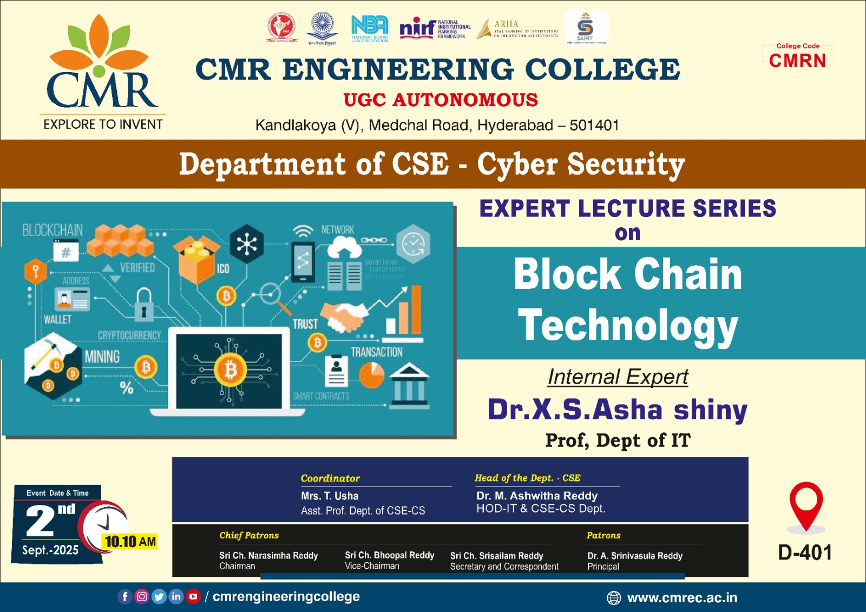
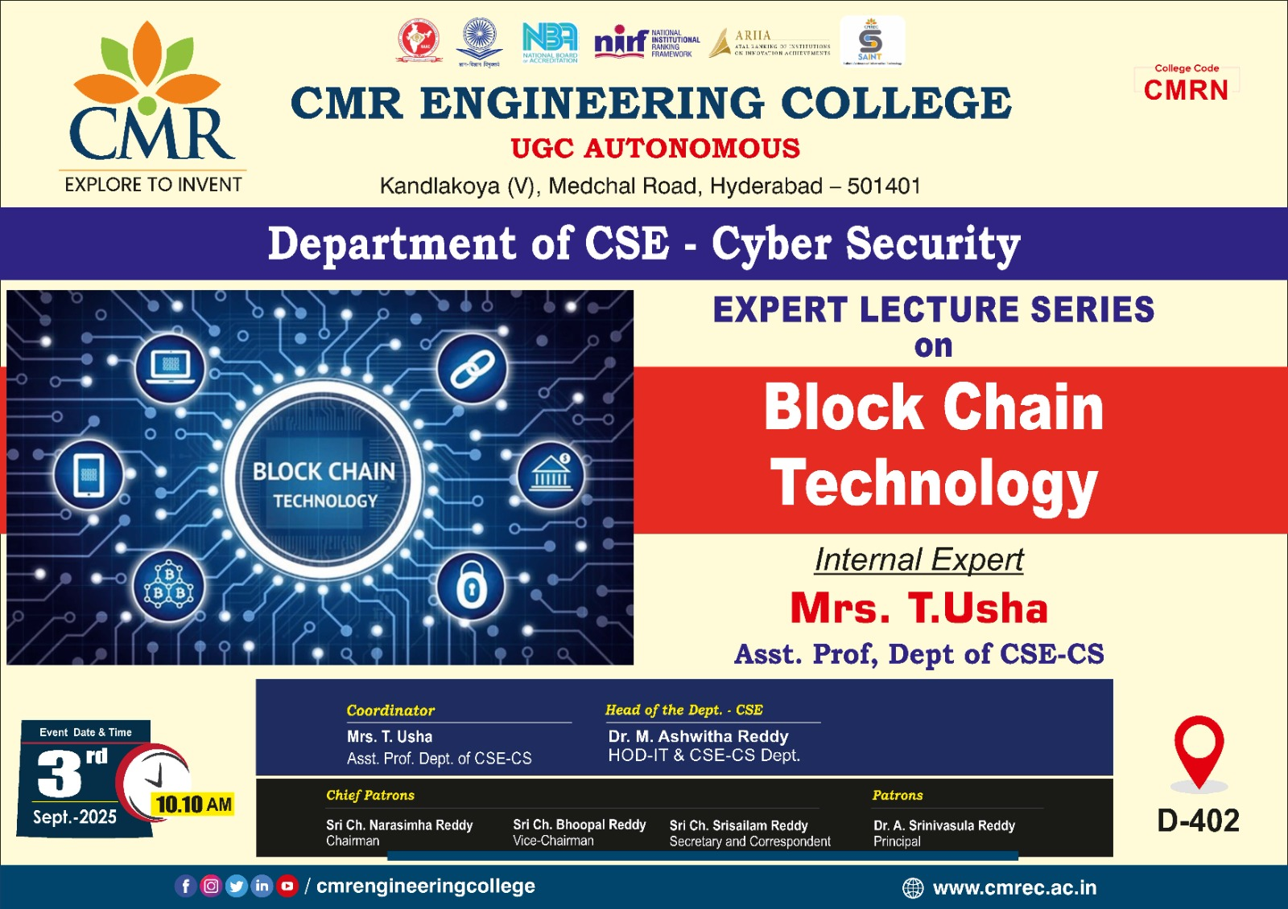

Photographs *

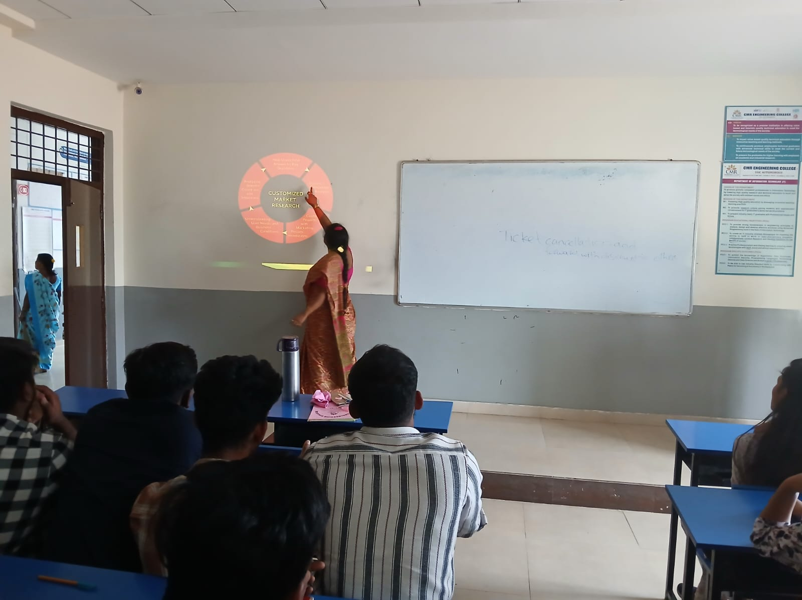

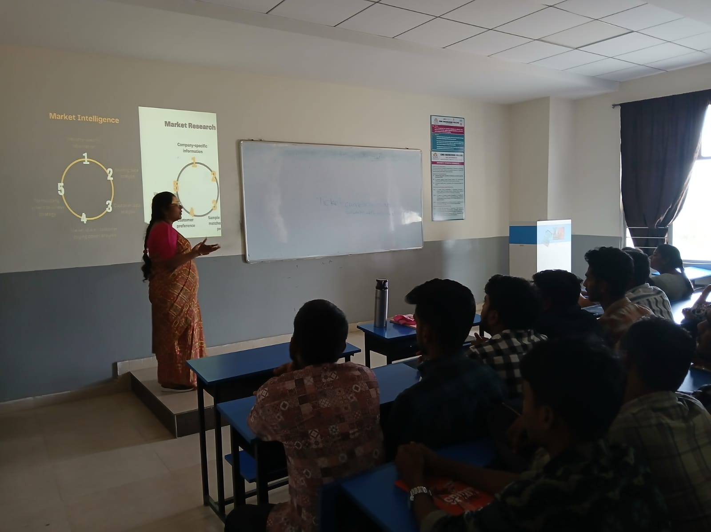
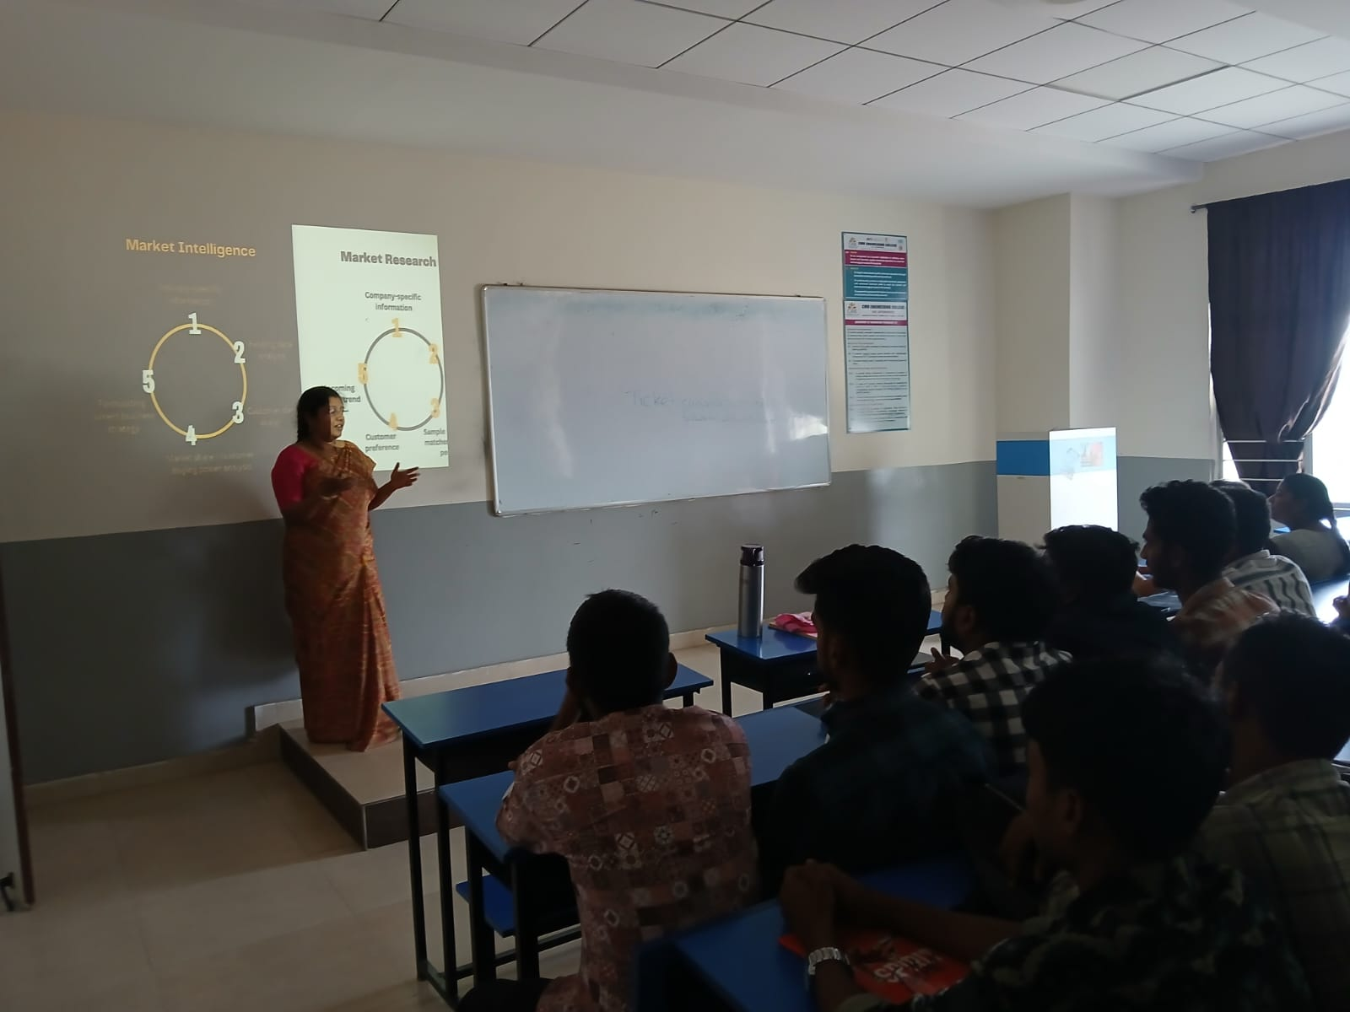

Department of Information Technology

A Report

On
“Expert Lecture Series on Design and Analysis of Algorithms”

Title of Event : Expert Lecture Series on Design and Analysis of Algorithms
Date of Event : 02/09/2025
Venue : Block-C 410
Internal Expert : Mrs. T.Sarika, Assistant Professor of IT.
Convener : Dr. M.Ashwitha Reddy , HOD-IT & CSE-CS dept
Coordinators : Mrs. Sushma Kariveda, Assistant Professor of IT.

Description

The Department of Information Technology has conducted the Expert Lecture Series on Design and Analysis of Algorithms on 02ND September 2025, 10.10 am. The event was presided by our Principal Dr. A. Srinivasula Reddy, HOD IT Dr.M.Ashwitha Reddy. The inaugural function came to an end by 10.30 am with national anthem sung by our students.
During the session Internal Expert discuss with the students to It’s about approaching the Divide and Conquer, Dynamic Programming, Greedy Method, Backtracking and Branch &Bound.
With the valedictory function on evening, the program came to an end. As a whole the program was a great success beyond our expectation, and for this we would like to thank our management and Principal for their full support and encouragement. We are also thankful to our respected HOD for her motivation and guidance.

Banner:
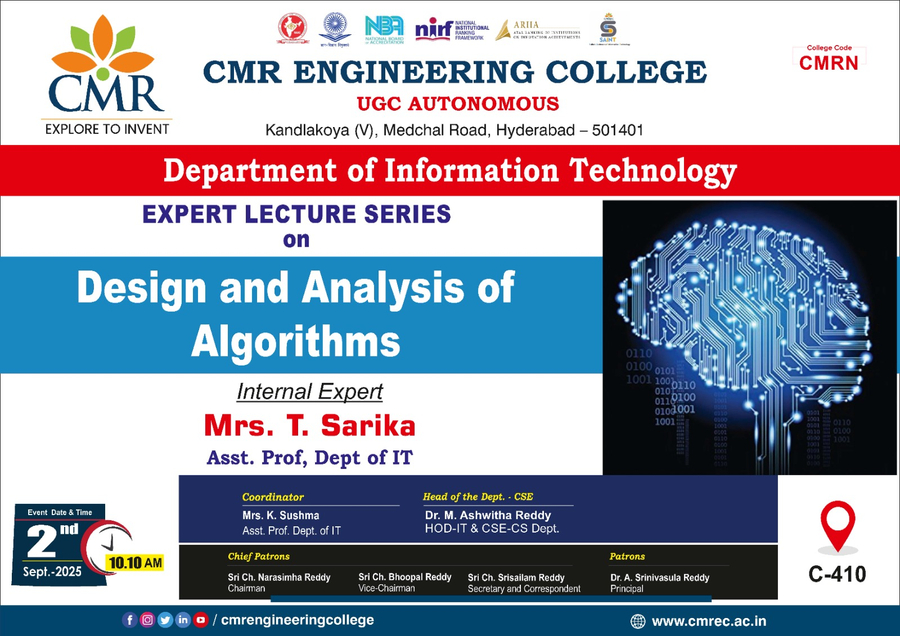
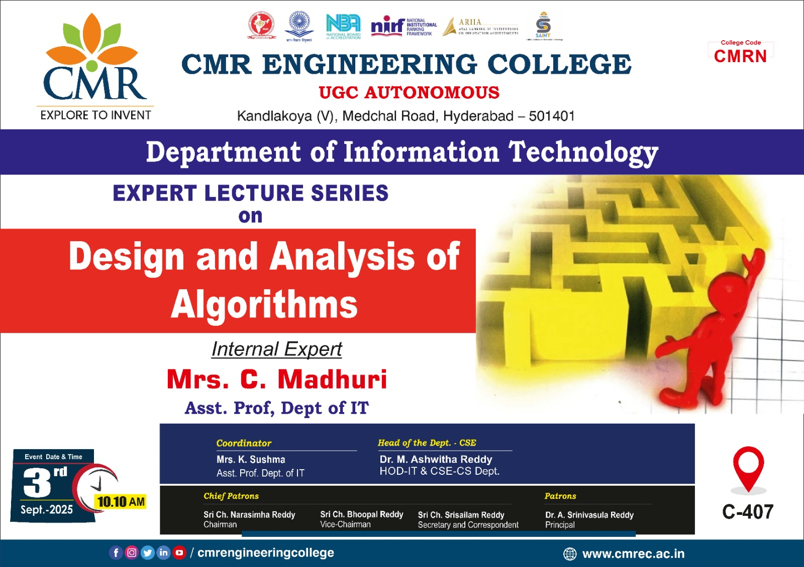

Photographs *

