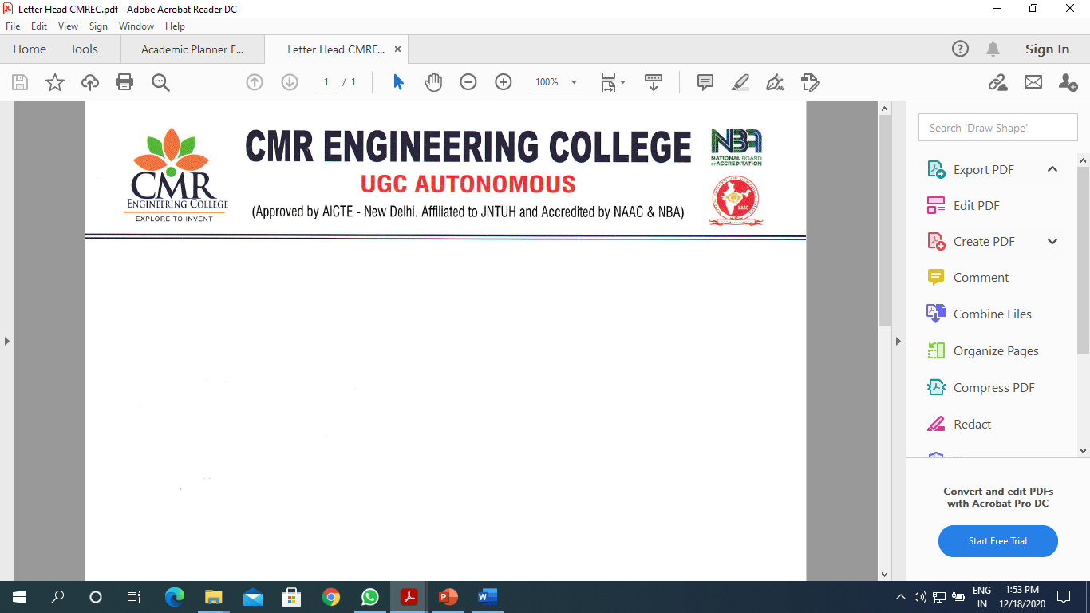
Department of Information Technology

A Report

On
“Lean Start-up &Minimum Viable Product/Business”-Boot camp (or)mentoring session

Title of Event : “Lean Start-up &Minimum Viable Product/Business”-Boot camp (or)mentoring session

Date of Event : 23/08/2025
Venue : Block-1 Auditorium
Resource Person : Mr.K.Subba Rayudu, Senior Manager, Wipro Technologies.
Convener : Dr. M.Ashwitha Reddy , HOD-IT & CSE-CS dept
Coordinators : Mrs. T.Usha, Assistant Professor of CSC.

Description

The Department of Information Technology has conducted the Talk on “Lean Start-up &Minimum Viable Product/Business”-Boot camp (or)mentoring session on 23th August 2025, 02.00 pm. The event was inaugurated by our chief guest Mr.K.Subba Rayudu, Senior Manager, Wipro Technologies. The event was presided by our Principal Dr. A. Srinivasula Reddy, HOD IT Dr.M.Ashwitha Reddy. The inaugural function came to an end by 02.30 pm with national anthem sung by our students.
During the session Resource persons discuss with the students to It’s about approaching challenges the way an entrepreneur or startup founder would — with curiosity, problem-solving, and a focus on creating value. Founders don’t wait for instructions; they identify opportunities, take calculated risks, and build solutions that make a real impact.
With the valedictory function on evening, the program came to an end. As a whole the program was a great success beyond our expectation, and for this we would like to thank our management and Principal for their full support and encouragement. We are also thankful to our respected HOD for her motivation and guidance.

Banner:
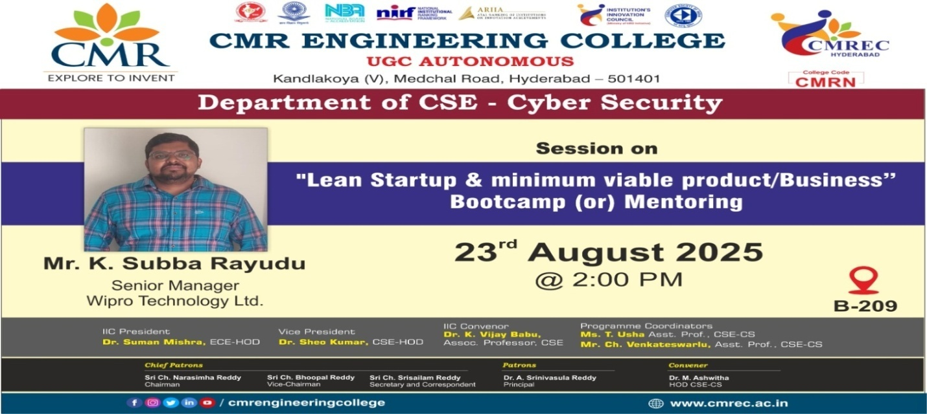

Photographs *

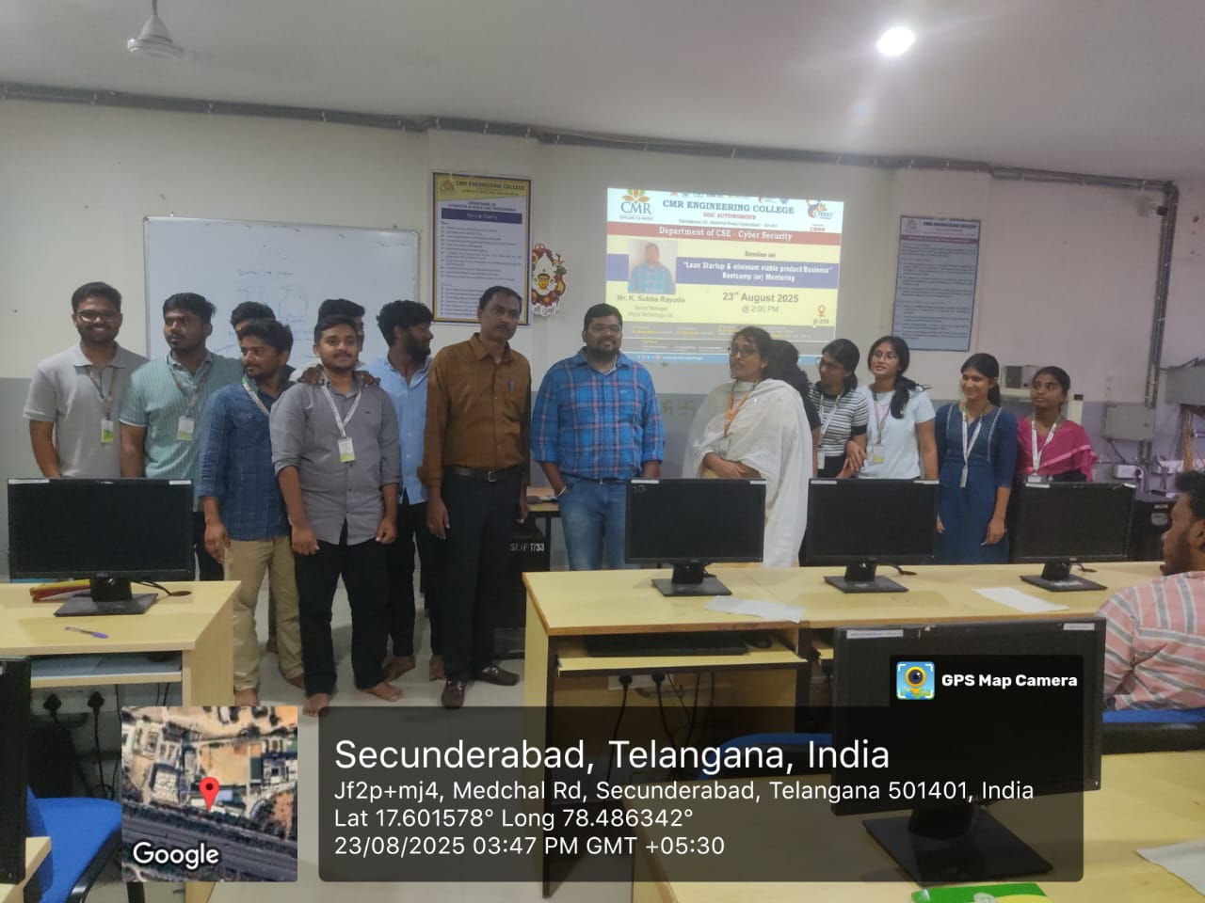

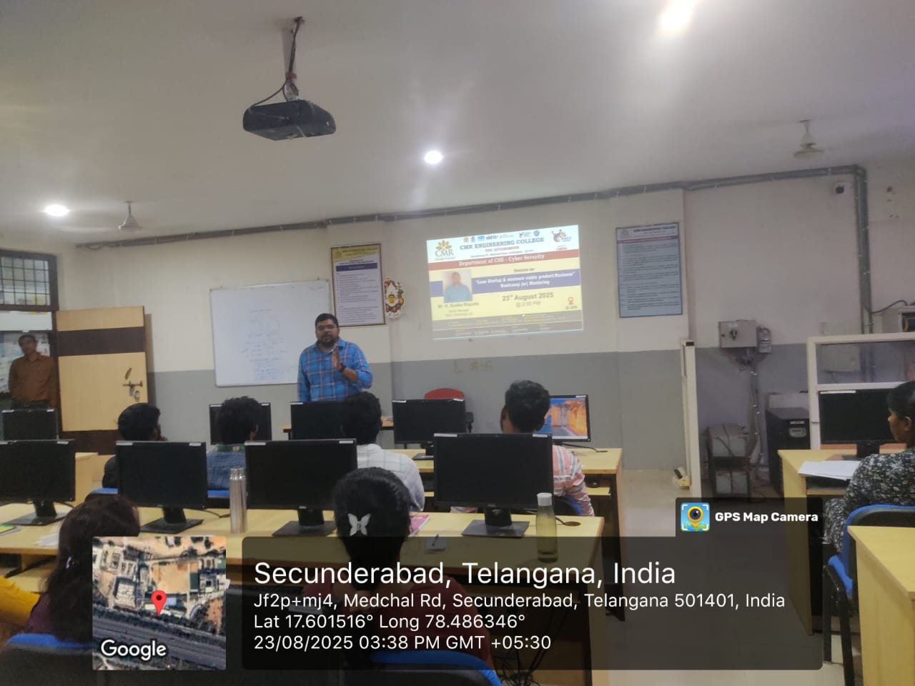

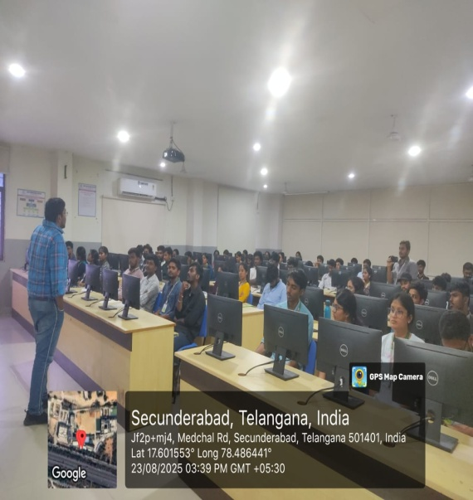

Department of Information Technology

A Report

On
“Think Like A Founder”

Title of Event : A Talk on “Think Like A Founder”
Date of Event : 26/08/2025
Venue : Block-1 Auditorium
Resource Person : Mrs. Anu Bulusu,Founder, Tech Leader, Author, INRY Tech Services Firms,U.S and Asia.
Convener : Dr. M.Ashwitha Reddy , HOD-IT & CSE-CS dept
Coordinators : Mrs. Sushma Kariveda, Assistant Professor of IT.

Description

The Department of Information Technology has conducted the Talk on “Think Like A Founder” on 26th August 2025, 10.00 am. The event was inaugurated by our chief guest Mrs. Anu Bulusu, Founder, Tech Leader, Author, INRY Tech Services Firms,U.S and Asia. The event was presided by our Principal Dr. A. Srinivasula Reddy, HOD IT Dr.M.Ashwitha Reddy. The inaugural function came to an end by 10.30 am with national anthem sung by our students.
During the session Resource persons discuss with the students to It’s about approaching challenges the way an entrepreneur or startup founder would — with curiosity, problem-solving, and a focus on creating value. Founders don’t wait for instructions; they identify opportunities, take calculated risks, and build solutions that make a real impact.
With the valedictory function on evening, the program came to an end. As a whole the program was a great success beyond our expectation, and for this we would like to thank our management and Principal for their full support and encouragement. We are also thankful to our respected HOD for her motivation and guidance.

Banner:
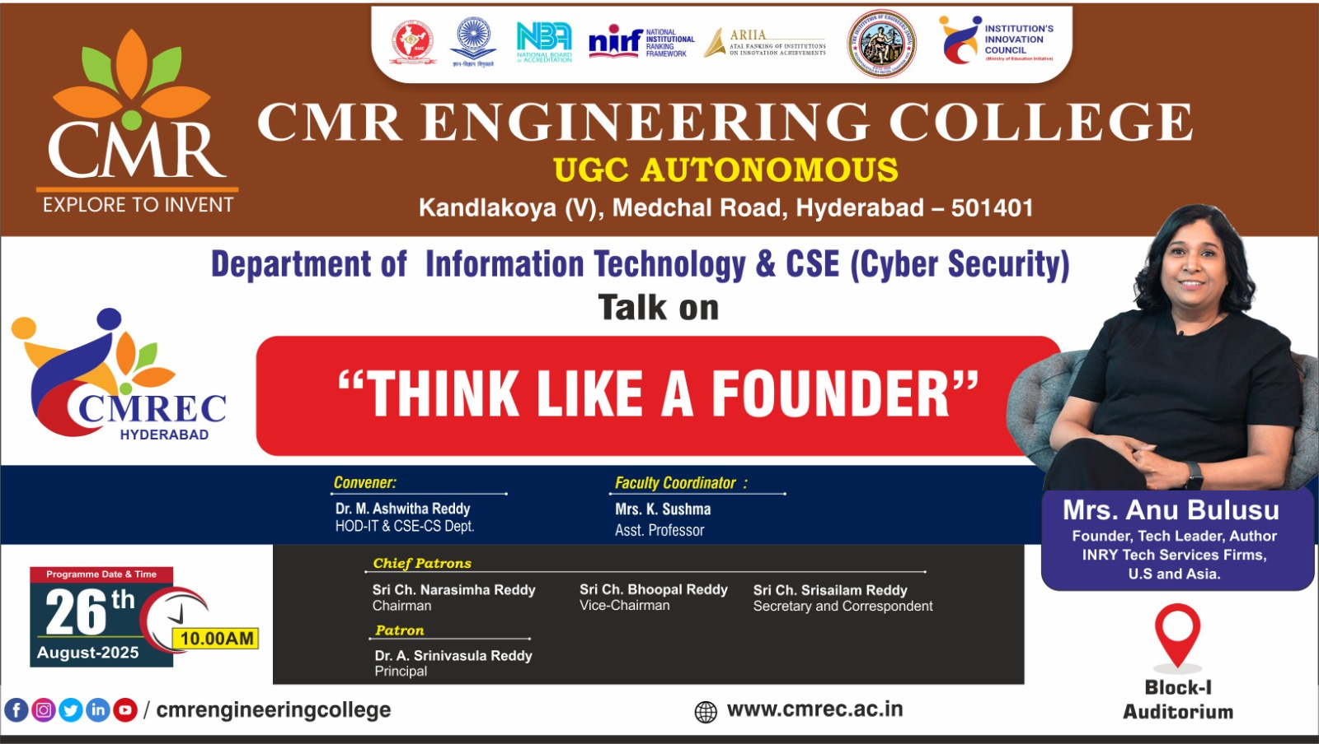

Photographs *

