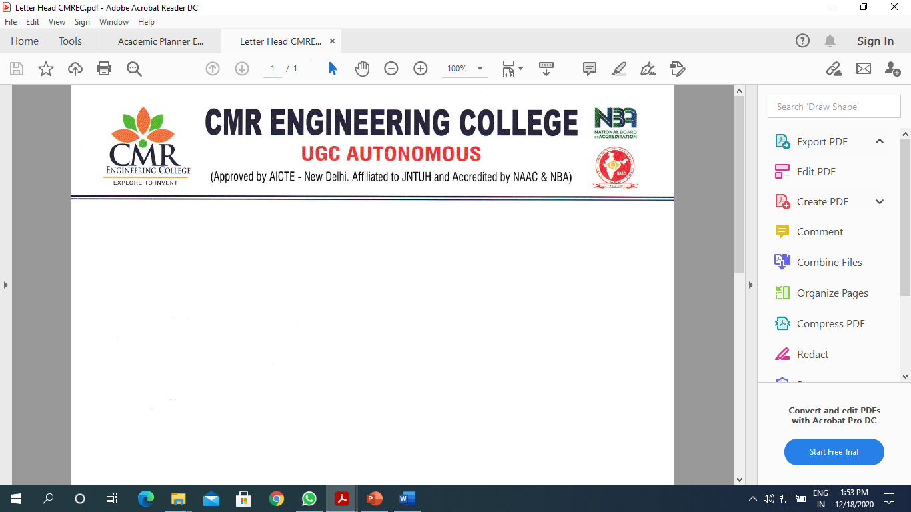
Department of Information Technology

Expert Lecture Series-1 Report

On
“COMPILER DESIGN”

Title of Event : Expert Lecture Series-1 on “COMPILER DESIGN”
Date of Event : 23/03/2024
Venue : E-201
Resource Person :Mr.L.B.Pandey Asst.Professor, Dept of CSE(AI&ML)
Convener : Dr. Madhavi Pingili , HOD-IT
Coordinators : Mrs. Sushma Kariveda, Assistant Professor of IT.

Description

The Department of Information Technology has conducted the Expert Lecture Series on “COMPILER DESIGN” on 23th March 2024, 9.30 am. The event was inaugurated by our chief guest Mr.L.B Pandey, Asst.Professor,Dept of CSE(AI&ML). The event was presided by our Principal Dr. A. Srinivasula Reddy, HOD IT Dr.Madhavi Pingili. The inaugural function came to an end by 10.00 am with national anthem sung by our students.
During the session Resource persons discuss with the students to Boot Strapping and Input Buffering, Role of error handler and types of error’s recognised in each phase of compiler Removal of Left Recursion and Left Factoring, SLR and CLR parsing Techniques, Relation between different parsing techniques, SDD and types of SDD.
With the valedictory function on evening, the program came to an end. As a whole the program was a great success beyond our expectation, and for this we would like to thank our management and Principal for their full support and encouragement. We are also thankful to our respected HOD for her motivation and guidance.

Banner:

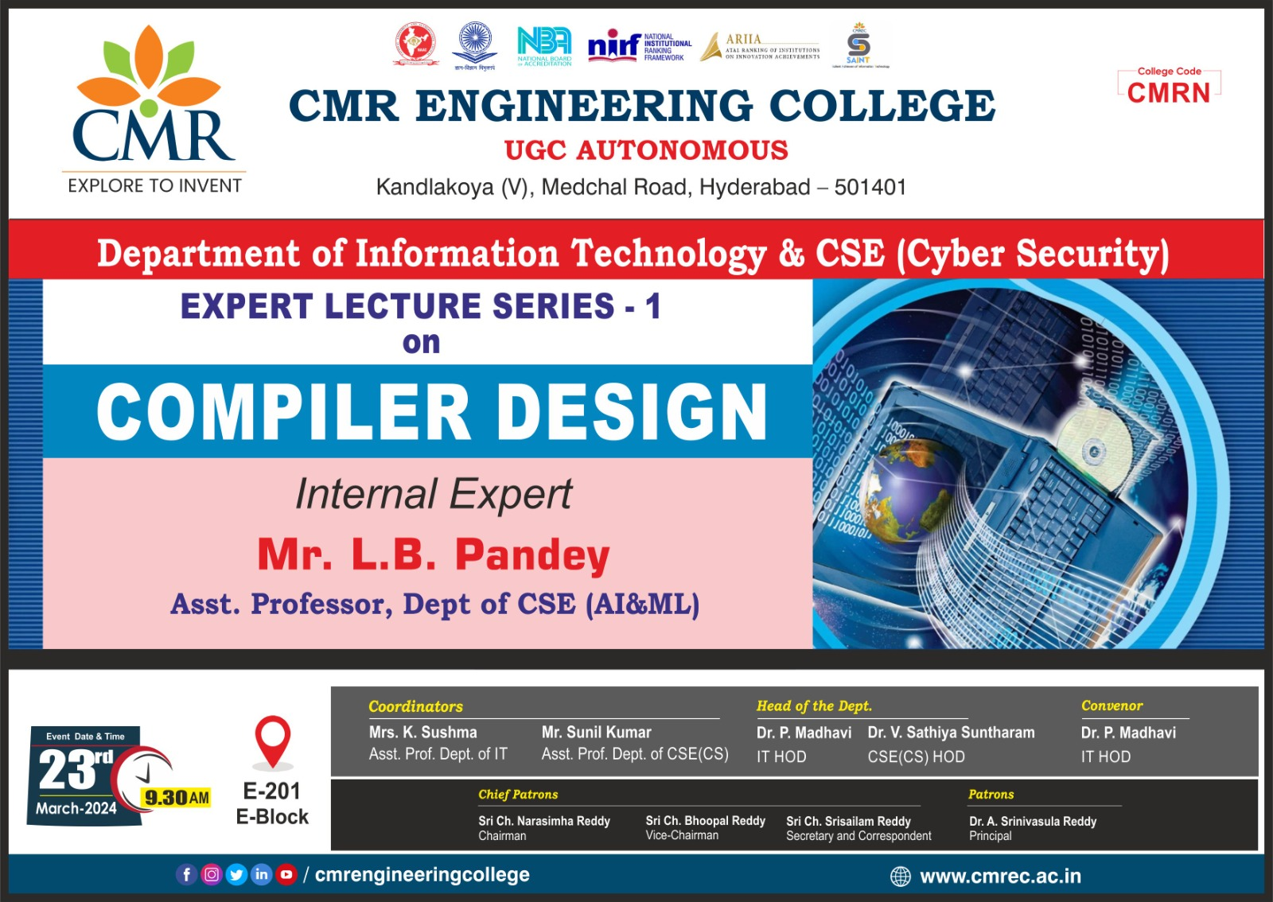

Photographs *

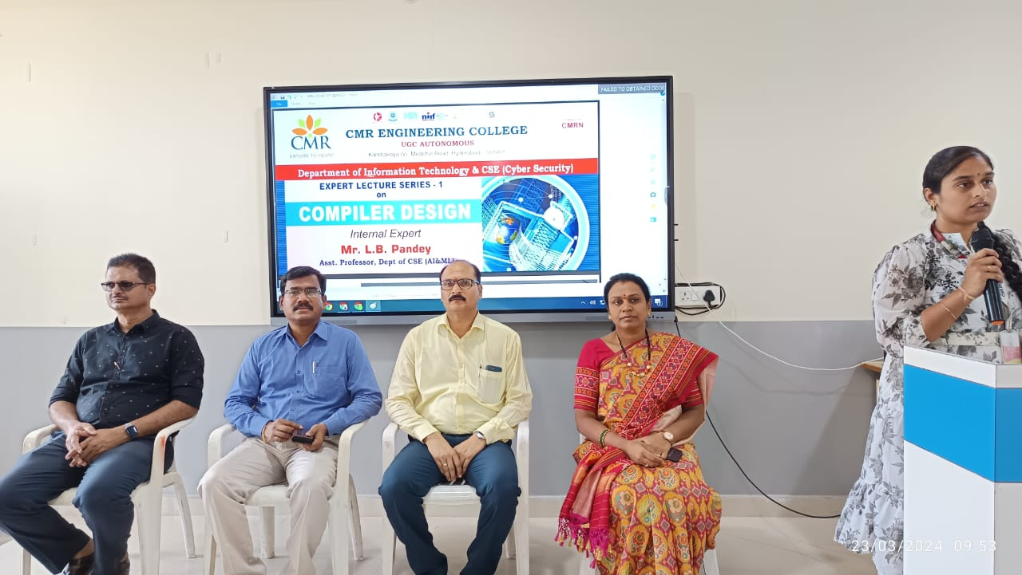

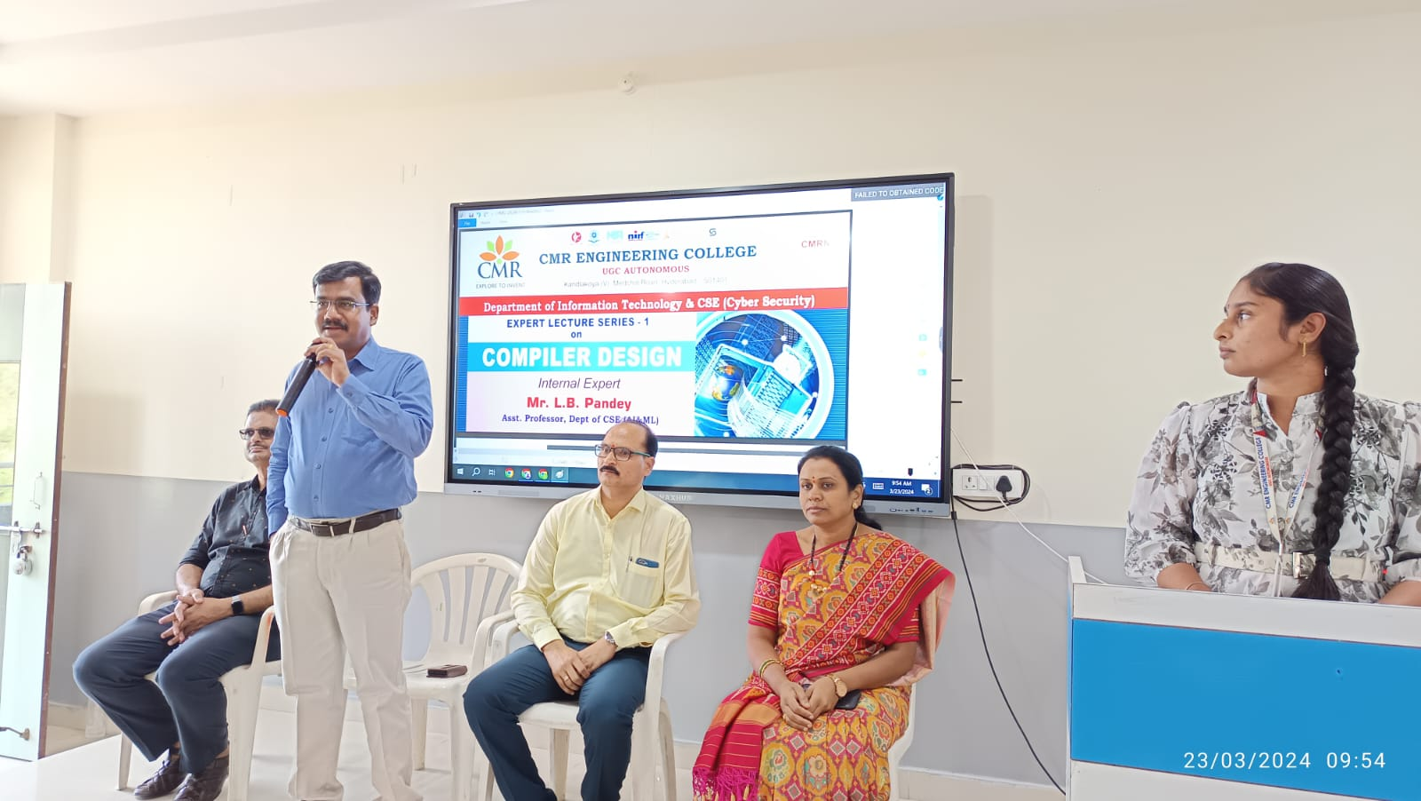

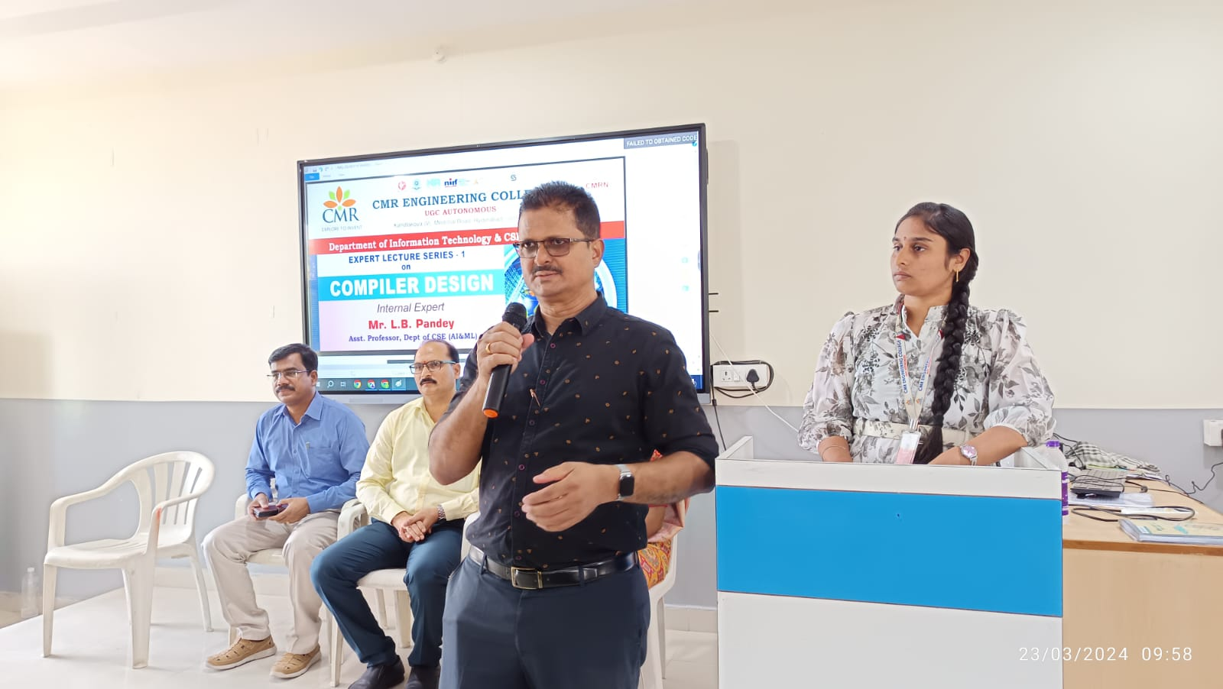

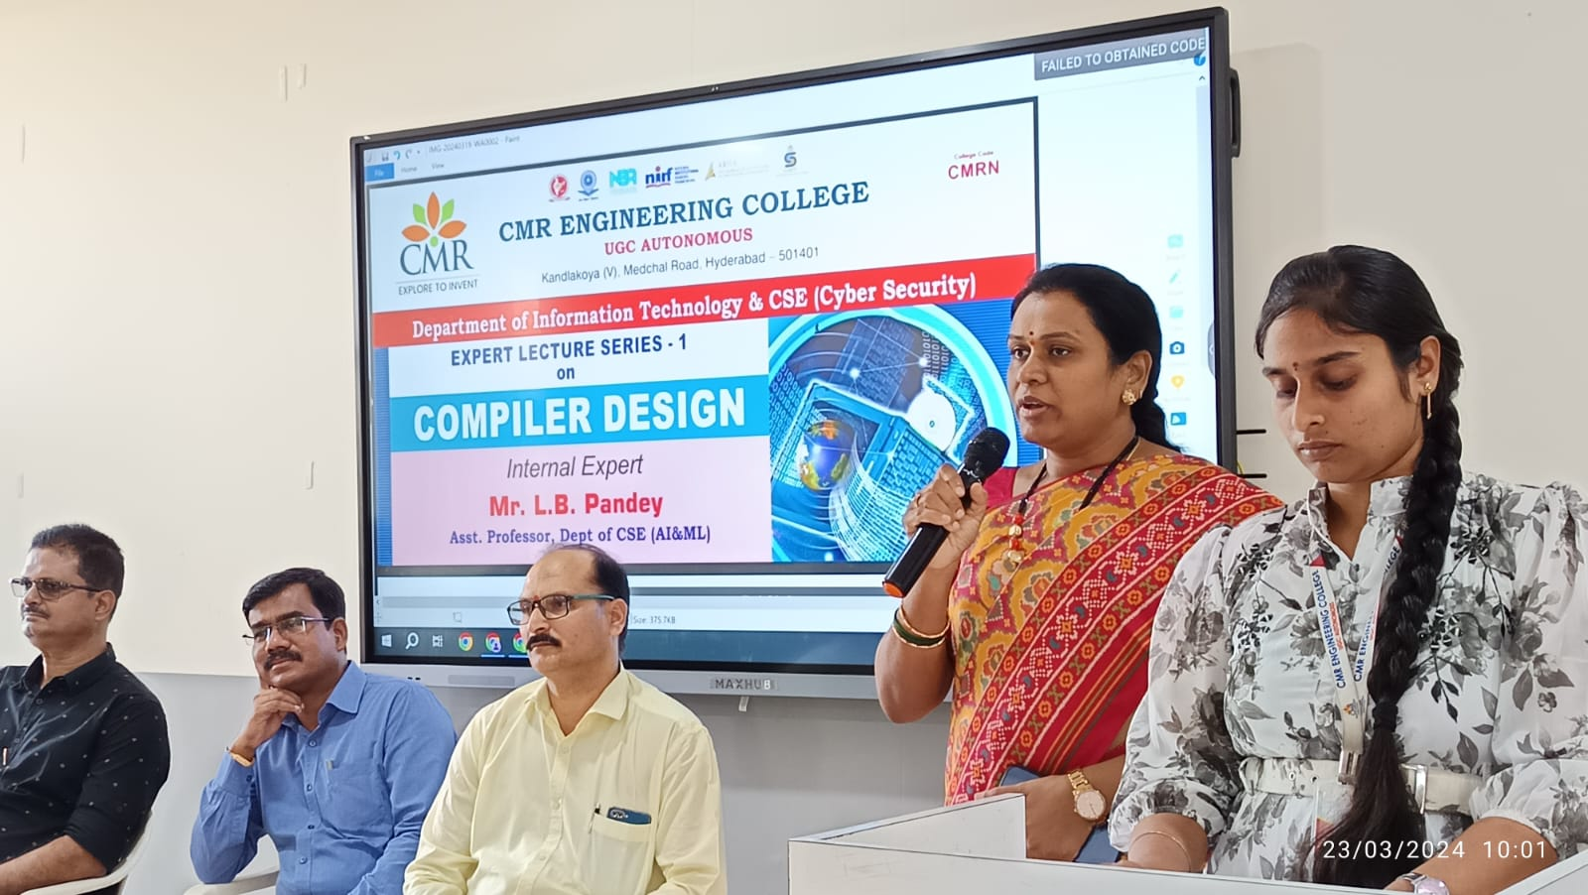

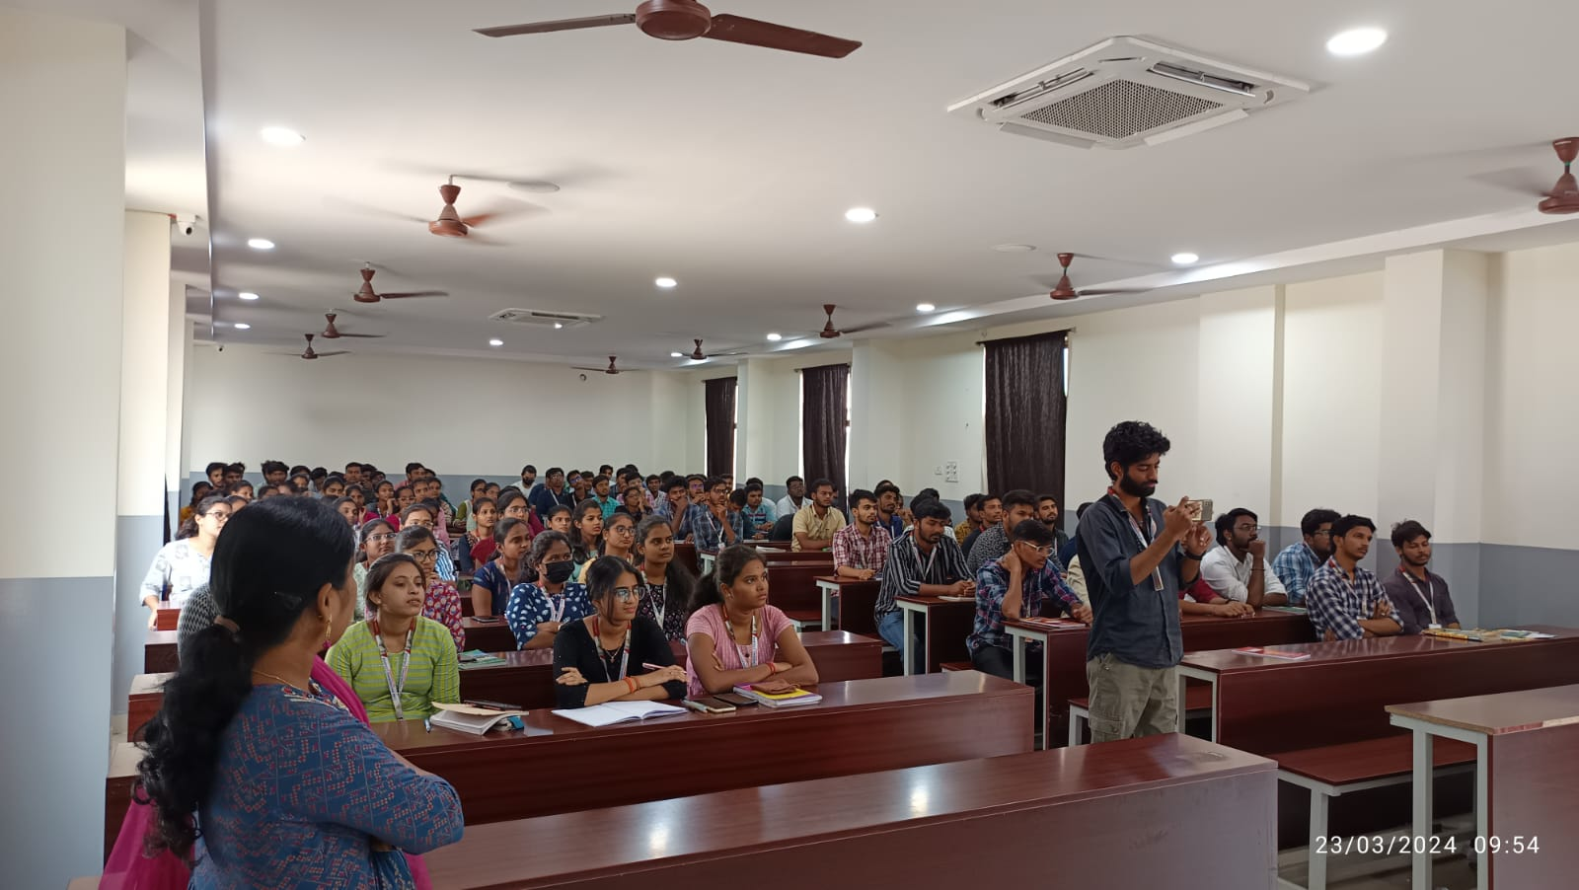
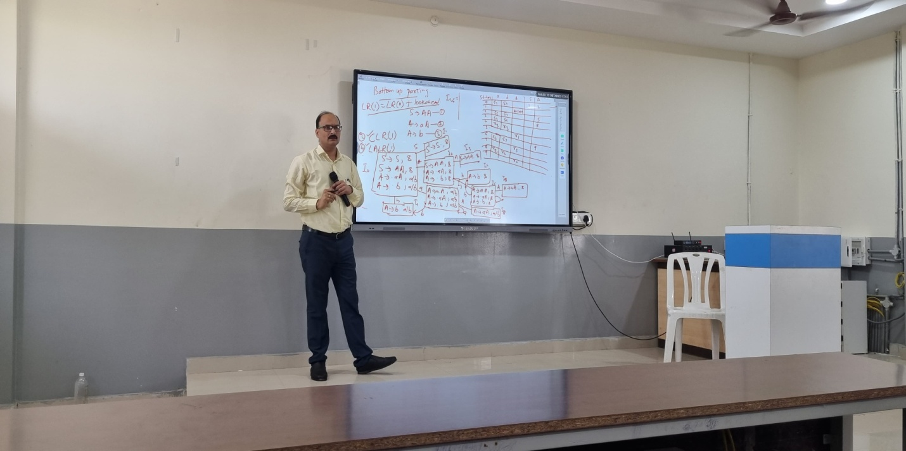
Department of Information Technology

Expert Lecture Series-2 Report

On
“Discrete Mathematics”

Title of Event : Expert Lecture Series-2 on “Discrete Mathematics”
Date of Event : 02/04/2024
Venue : E-201
Resource Person : Mr. K.Ramana Reddy Assoc.Professor, Dept of CSE
Convener : Dr. Madhavi Pingili , HOD-IT
Coordinators : Mrs. Sushma Kariveda, Assistant Professor of IT.

Description

The Department of Information Technology has conducted the Expert Lecture Series on “Discrete Mathematics” on 02nd April 2024, 9.30 am. The event was inaugurated by our chief guest Mr. K. Ramana Reddy, Assoc. Professor, Dept of CSE. The event was presided by our Principal Dr. A. Srinivasula Reddy, HOD IT Dr. Madhavi Pingili. The inaugural function came to an end by 10.00 am with national anthem sung by our students.
During the session Resource persons discuss with the students to Statements, Truth tables, logics and proofs, Normal Forms and Problems related to Normal forms.
With the valedictory function on evening, the program came to an end. As a whole the program was a great success beyond our expectation, and for this we would like to thank our management and Principal for their full support and encouragement. We are also thankful to our respected HOD for her motivation and guidance.

Banner:

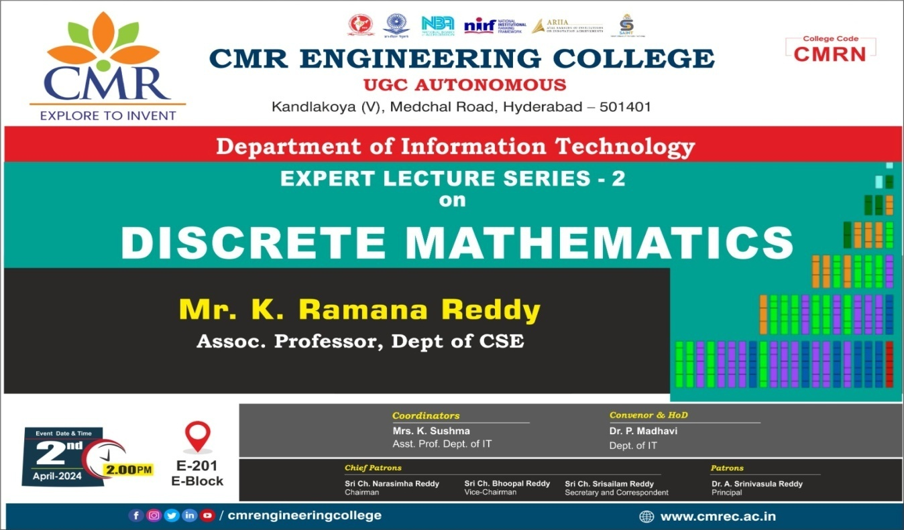
Photographs *

