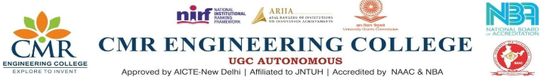
DEPARTMENT OF HUMANITIES AND SCIENCES
Name of Event: Guest Lecture on Skill Development
Date of Event: 22nd–23rd August 2025
Resource Person: Maharshi Sagar, Vice-President, Ramanuja Maths Academy, and Additional Secretary, South India Maths Teachers Association.
Mr. Maharshi Sagar delivered highly interactive and inspiring sessions focusing on the importance of communication skills, analytical thinking, time management, and adaptability in today’s competitive world. To ensure a closer connection with students, he engaged with all sections and departments separately, tailoring his interaction style to their specific needs.
The sessions included practical activities, real-life examples, and motivational guidance that encouraged students to develop confidence and responsibility in both academics and personal growth. Students actively participated and raised queries, which were addressed with clarity and encouragement by the speaker.
The program proved to be insightful and impactful, helping students realize the importance of soft skills alongside technical knowledge in shaping their careers.
