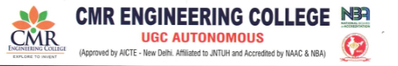
DEPARTMENT OF HUMANITIES AND SCIENCES
Name of the Event: Introduction to Department
Date of Event:26/08/2025
Resource Person: Dr.Laxmaiah, HOD of CSE (Data science)
The Department of Data Science, CMR Engineering College, organized an introductory session for first-year students to familiarize them with the scope and importance of Data Science. The program was held in the college auditorium with active participation from the freshmen.
The session covered the basics of Data Science, explaining how it extracts knowledge and insights from data. Students were introduced to its core components such as data handling, programming, visualization, and interpretation. The importance of Data Science in various fields like healthcare, finance, retail, education, and governance was highlighted with practical examples.
Speakers emphasized the career opportunities and future prospects in this fast-growing field and motivated students to focus on analytical and technical skills. The session ended with an interactive Q&A, leaving students inspired and better informed about the role of Data Science in today’s digital era.
