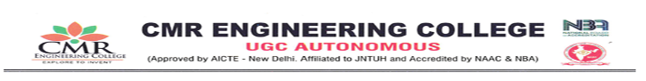
DEPARTMENT OF HUMANITIES AND SCIENCES
Name of the Event: Lecture on “C-Programming Concepts”.
Date of Event:1/11/2025
Venue: Block E -102
Resource Person: Dr. Sayaad Rasheeduddin, Associate Professor, CMREC.
An Internal Expert Lecture was conducted at CMR Engineering College (CMREC) to enhance students’ understanding of programming fundamentals and their real-world applications. The session was delivered by Dr. Sayaad Rasheeduddin, Associate Professor, CMREC.
The lecture focused on the basics of C programming, covering fundamental concepts such as program structure, data types, control statements, and logical flow. The speaker explained the importance of C as a foundational programming language for engineering students and its relevance in developing problem-solving skills.
To provide practical exposure, Dr. Rasheeduddin discussed the application of C programming in developing real-time projects. He elaborated on Library Management System and Bus Reservation System as example projects, explaining how C programming concepts are implemented to handle data storage, user interaction, and basic system operations. These examples helped students understand how theoretical concepts are translated into practical solutions.
The session was interactive and concept-oriented, enabling students to gain clarity on programming logic and application development. The lecture effectively strengthened students’ foundational knowledge and motivated them to apply C programming concepts in mini-projects and academic assignments.
The expert lecture concluded successfully, contributing to the enhancement of students’ technical competence and practical understanding of C programming.

